# Misc.

**How To Update Your Status During Stand-up Like a Senior Engineer**

A status update is where you can showcase how well you manage ambiguity and is an important way to build trust with your team. The simplest way to convey a status update in a stand-up meeting is to talk about what you did yesterday, what you will do today, and if there are any blockers. Even if you don’t have any PR or documentation ready, don’t be afraid to discuss what you did yesterday. It includes telling the team that you are spending time trying to understand the new architecture or the product definition for the entire day. The manager wants to know whether or not you are blocked during this status update. However, most importantly, they want to hear the delta of what you did yesterday compared to today. A status update is a good environment to reiterate your efforts on the project and set timeline expectations, such as any delays in the project delivery.

“Currently, I am blocked from testing this feature because the staging environment has an IP address deny list. I have submitted a ticket request to include my IP in the allow-list to test the feature X. Do you know a way to test this feature in the staging environment without the IP address?” “I messaged A yesterday and am still waiting for their response. If I don’t hear from A today, I will message them again or ping manager B for further guidance.”

Create a short summary list before the status update.

1. What did I do? - Research on System X and Product Spec Y. Found out that System X requires IT approval.
2. What will I do? - Look into the codebase of architecture X. Does anyone know which repository I should start with or who the owner of system X is?
3. Blockers - No Blockers for now

An example of a bad status update - “Trying to implement the payment processor routing yesterday by first scouting out the required product input. I have created four ways to implement this, one of them using a priority queue to determine the next best payment processor to implement using Free Monad to decouple the program structure flow and the interpreter. One of the benefits of using Free monad is …..”

An example of a better status update - “Trying to implement the payment processor routing yesterday by first understanding what product requirements we need to route our payment processors. In addition, I have written a brief documentation of four ways to do it, and I think the one with a priority queue may be the most suitable for solving the routing problems. I will paste them on the channel after stand-up, so please check it out!”

“I didn’t get to spend much time on project X because I was doing the hotfix for incident Y yesterday.”

“I am working on a feature, and I realized that testing this feature takes a long time. Therefore, I created a script to help speed up our testing during development. If anyone is interested, feel free to ping me later after the stand-up for more details. What will I be doing today? Task X is finished and only requires testing, so I will use the script I developed yesterday to do the testing today.”

Remember these four tips can help you make a good impression during your status update:

1. Create a short list before the status update: an unordered list helps to increase the flow of your speech.
2. Speak in layman’s terms: don’t go too deep into the weeds; keep it concise so everyone can understand.
3. Include other commitments in your status updates: include anything unexpected that takes up time and delays your progress.
4. Explain why the work matters in your status update: always think about how the update may impact another team member/department/company.

# Presenting to the Boss(es)

“If you want me to give you a two-hour presentation, I am ready today. If you want only a five-minute speech, it will take me two weeks to prepare.” – Mark Twain

Goals of the presentation – educate, persuade, inspire, request $, update on project, competitive/product analysis.

Anatomy of a presentation – beginning (first impression, no do-over, stories and questions), middle (compelling), end (review the highlights).

BP – put stories and questions before starting a presentation. Put review of highlights and what next in the last of the presentation, don’t put any distractions at the end. Also, envision a successful presentation by having a meditative state. Keep slides for backup if something doesn’t goes right like functional demo. Be on camera, ask questions from people randomly to keep them engage, don’t monolog too long but ask question in-between. Do a retrospective after the presentation to work upon any observations like any good point raised during presentation, sending response to some participant for a question or strengthen the relationship.

Practice articulating instead of doing mumbling.

Don’t makeup for the question if you really don’t know its answer, just say that you don’t know but will get back with you with answer.

# PowerPoint 2019 Pro

We can insert hyperlink, morphed transition, slide master, custom slide layout.

We can make gridlines visible to put the element on slide precisely.

We can also create second slide master to have a different layout from main slide master.

Handout master will help to change the layout for printing the slide.

Notes master will help to change the ways notes gets print while printing the slide.

We can add smart art graphics from Design tab.

We can also add audio clips, video clips, can adjust media window size.

We can also compare two presentations.

We can rehearse the timing which will show the timing bar with details to check the time to change and other actions.

We can also open the presenter view (speaker view) along with presentation view, presenter view will also show the notes, highlighter.

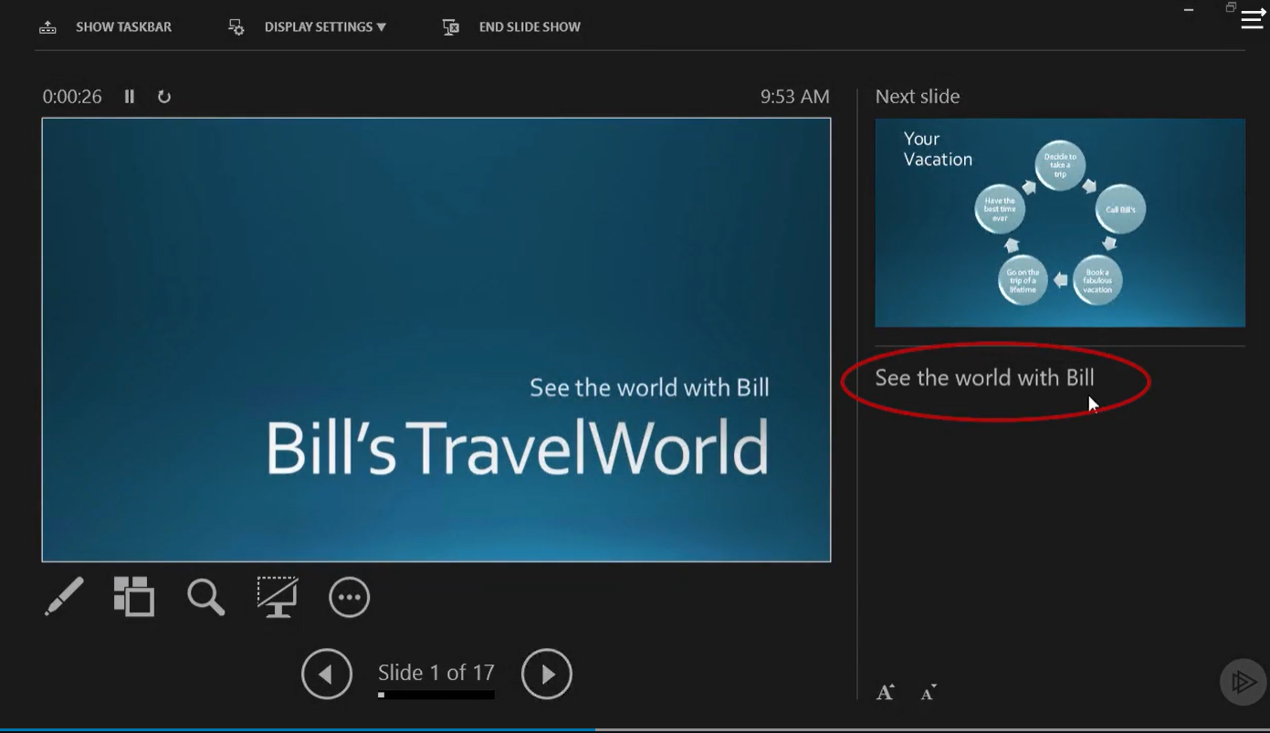

BP – Use presenter view while giving presentation. Before finalizing the presentation, do a spell check, inspect for any issue like document inspection, checking accessibility and check compatibility.

We can protect the PPT by setting password, restrict access, signing it with digital signature, marked as final.

We can also create PDF or Video file or handouts (like word document) from the presentation. We can also change the file type to .odp, .pppsx or older .ppt, .pptx, .png, .jpeg.

# PowerPoint 2021 Essentials

Structure – ribbon, tabs, backstage area -> pages (in file menu), slide pane, slide area.

We can also use ruler to draw exact line –

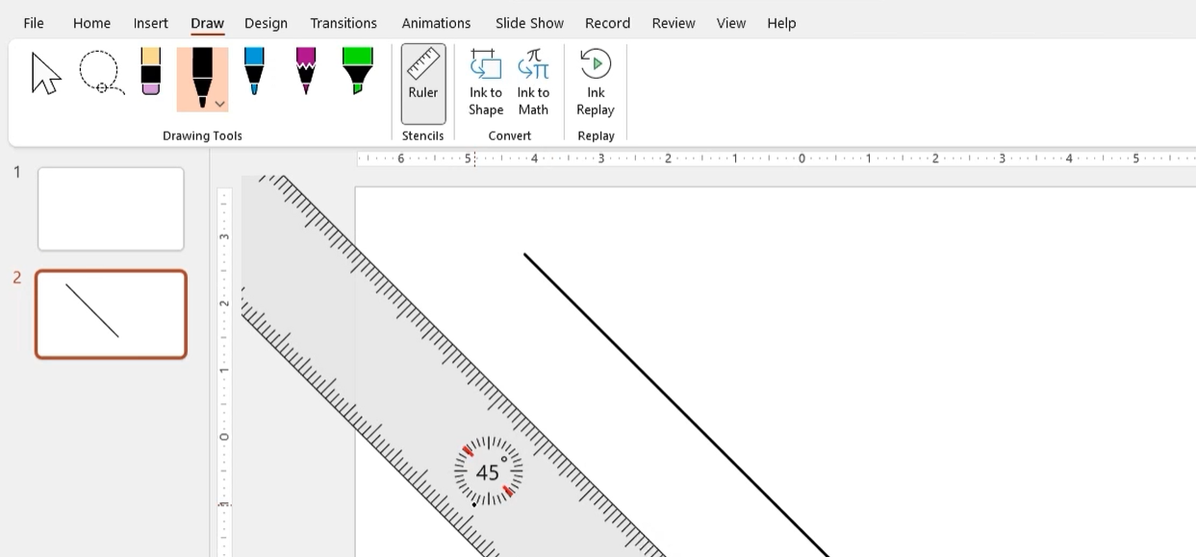

Ink to shape, to draw and image into perfect image –

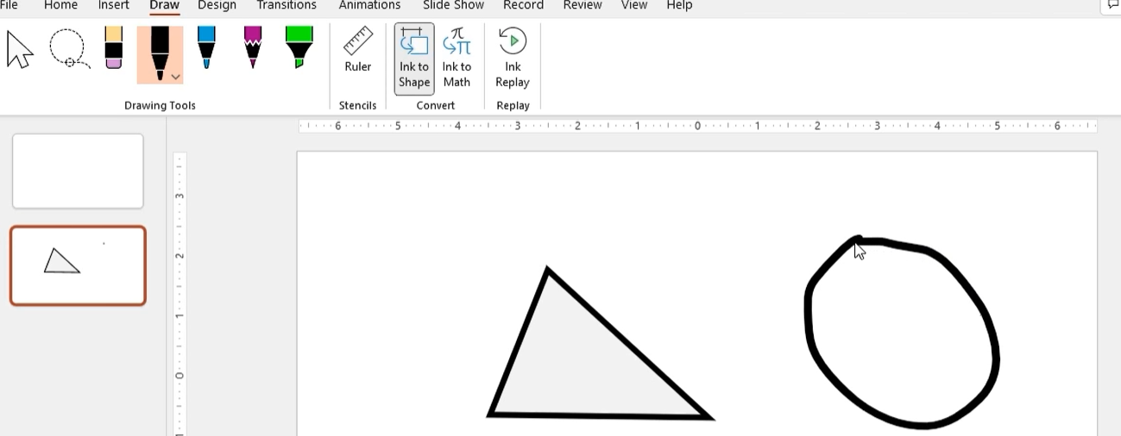

BP – Use thesaurus to find the word with the same meaning. Use insights option to get more information about a certain topic –

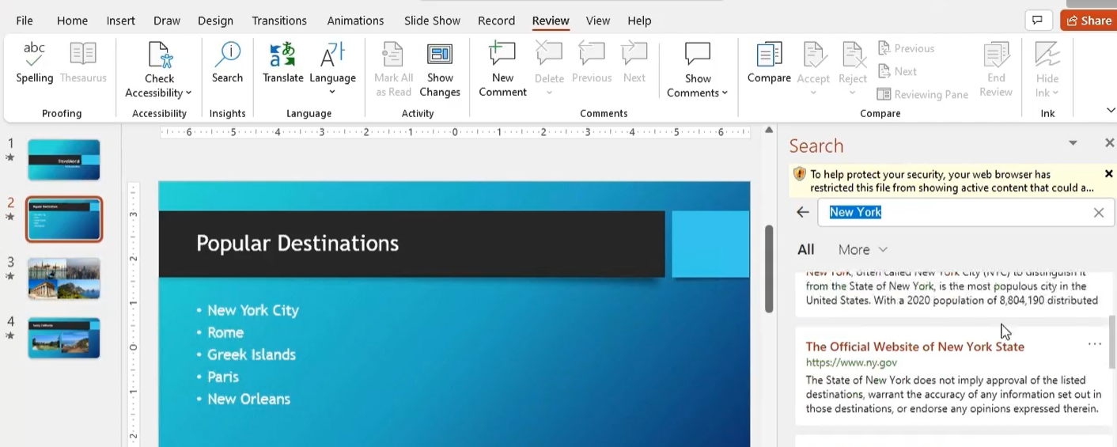

We can add different type of slide layouts like title slide, title and content, section header, two content, comparison, title only, blank, content with caption, picture with caption.

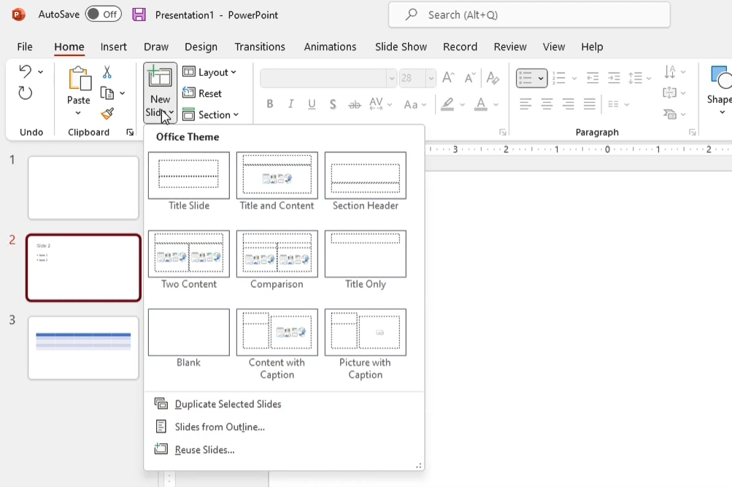

We can only set the size of the box only –

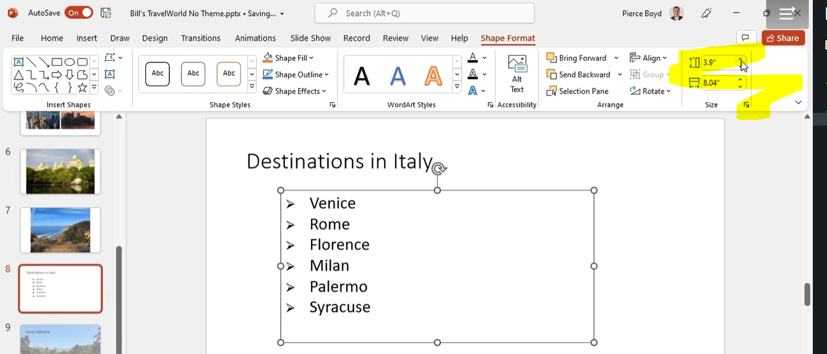

BP – Add online or stocks (from Microsoft) images instead of using the built-in ones.

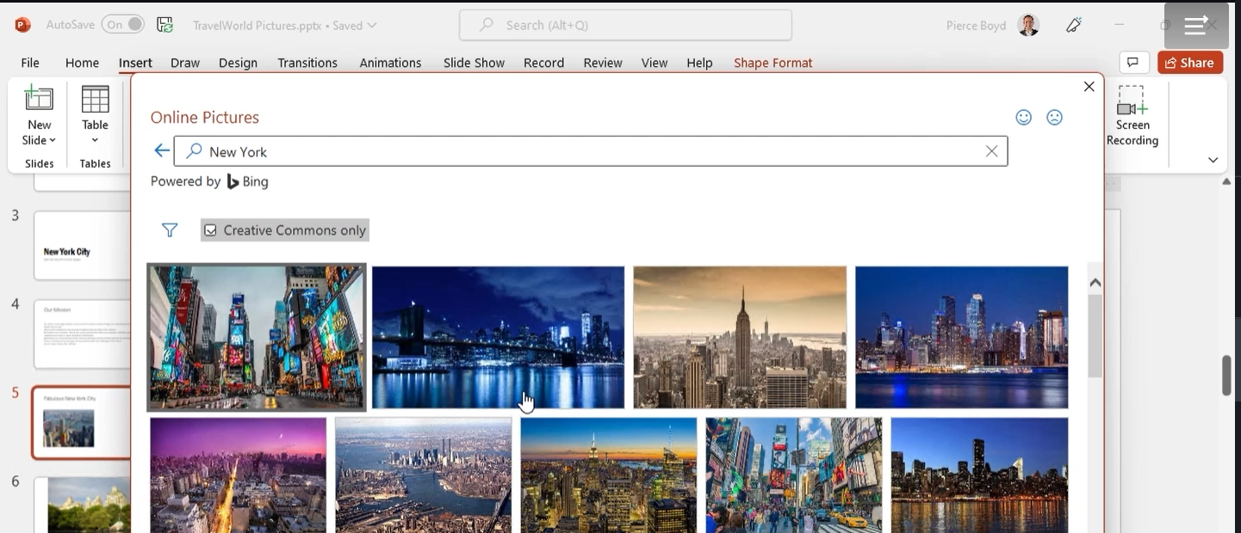

# Harappa – Young Leaders Program – Managing Teamwork

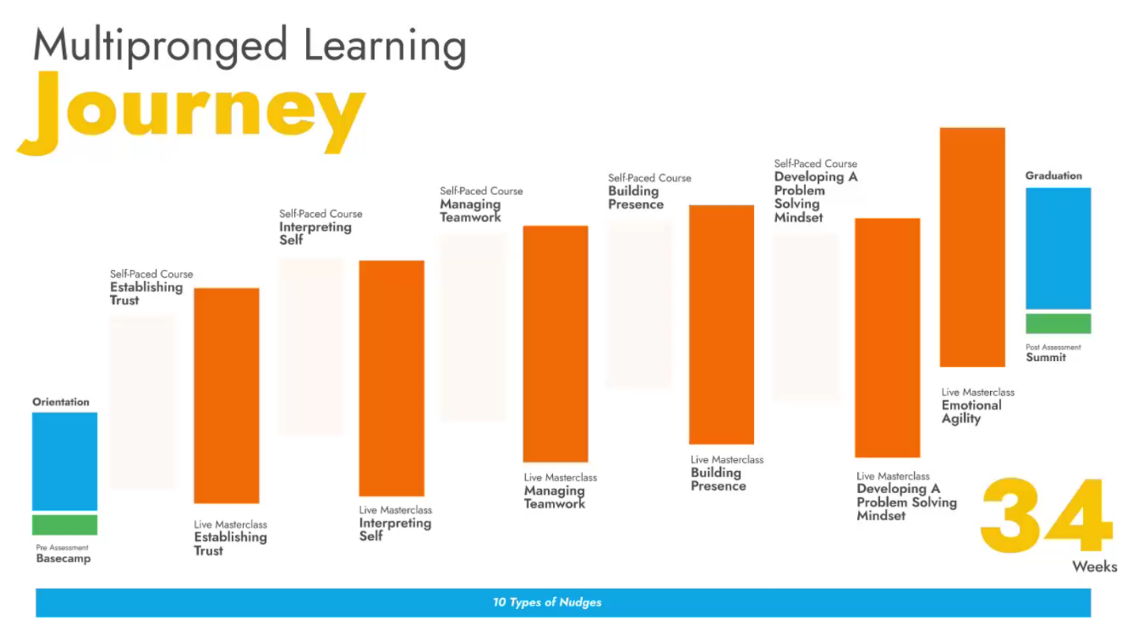

A good example Thai rescue team. For any work project to succeed, individuals have to learn to communicate, collaborate and coordinate like the Thai cave rescue team.

Harappa GRIN framework – shared goals, clear roles, strong interdependence and established norms.

Assign shared goals instead of individual teams goals, clear goals like serving food in restaurant, interdependence is like blocks in Sudoku the why are connected to each other. Norms covers how a team should work like discipline, modes of communication, and overall conduct.

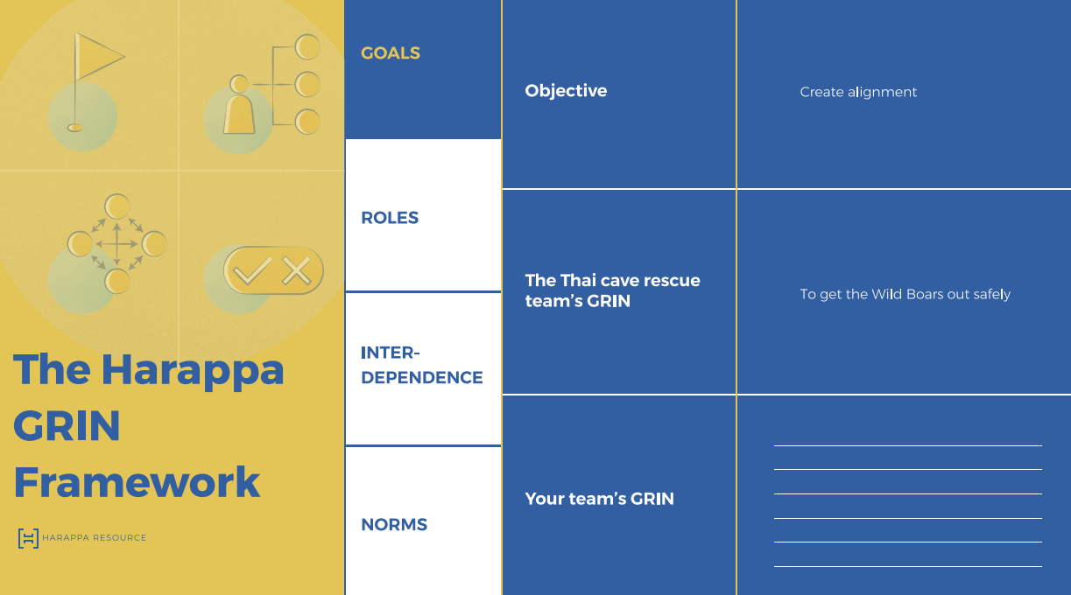

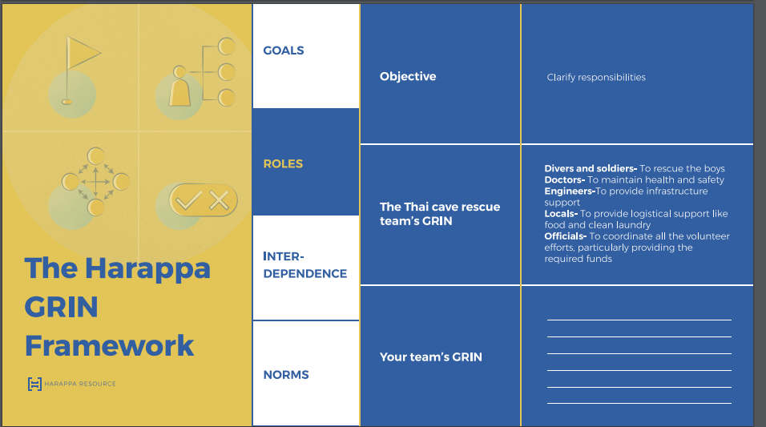

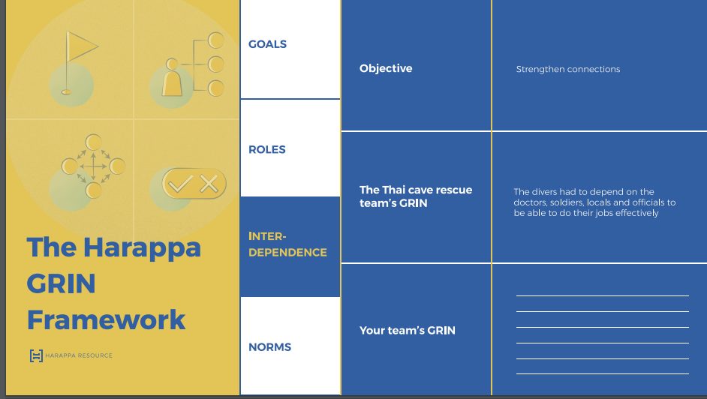

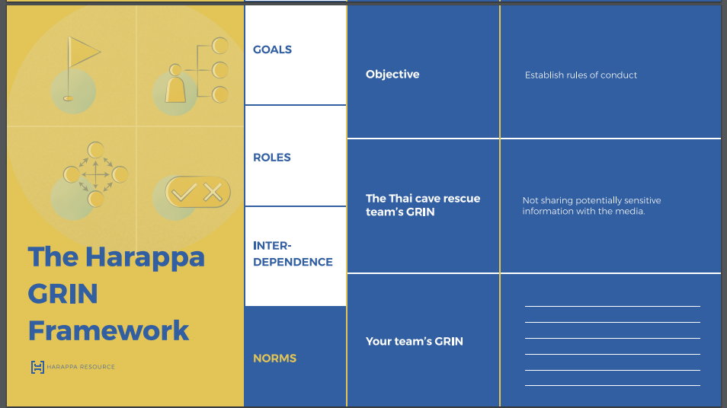

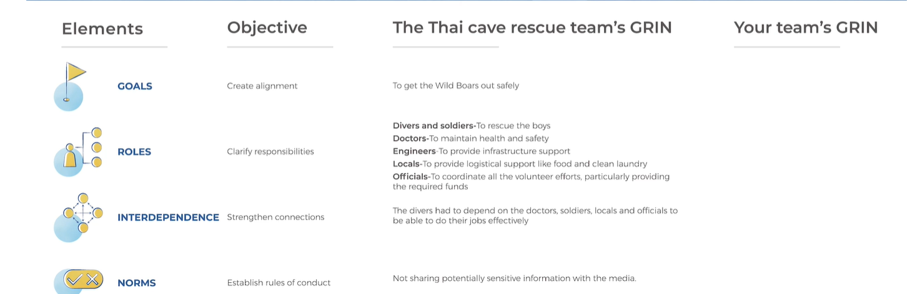

Bruce Tuckman model – forming, storming, norming and performing.

The forming stage is the best time to discuss and articulate goals, roles, interdependencies and norms. Also, this is a stage for discovery and understand things.

In storming stage the team members should listen to each other, trust one another and remain confident of their abilities. This phase is part of team’s evolution, the tensions and conflicts need not be permanent. We should rely on the power of honest conversation and empathy to improve working relationships.

Norming stage –

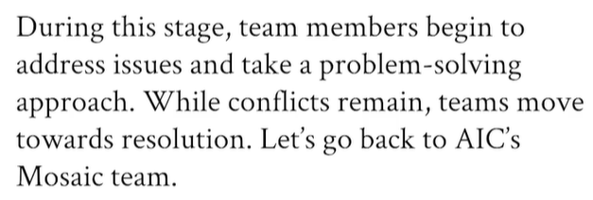

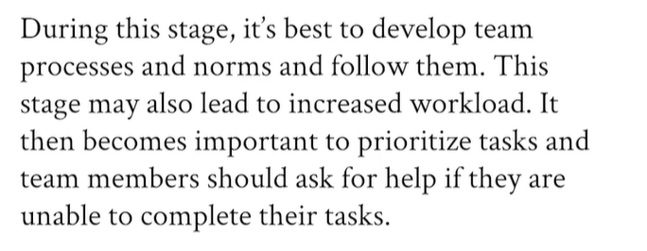

Performing stage – this stage is marked by high productivity. Team members are focused on delivering. They are not distracted by interpersonal issues.

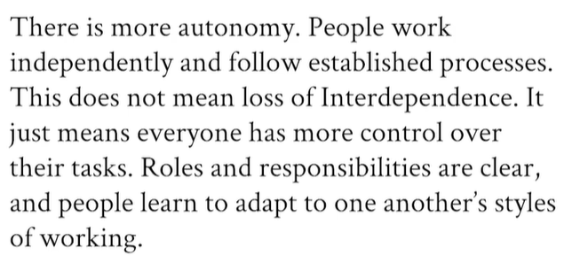

Mantra to get away from Storming phase –

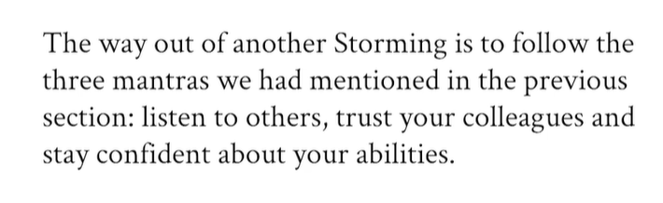

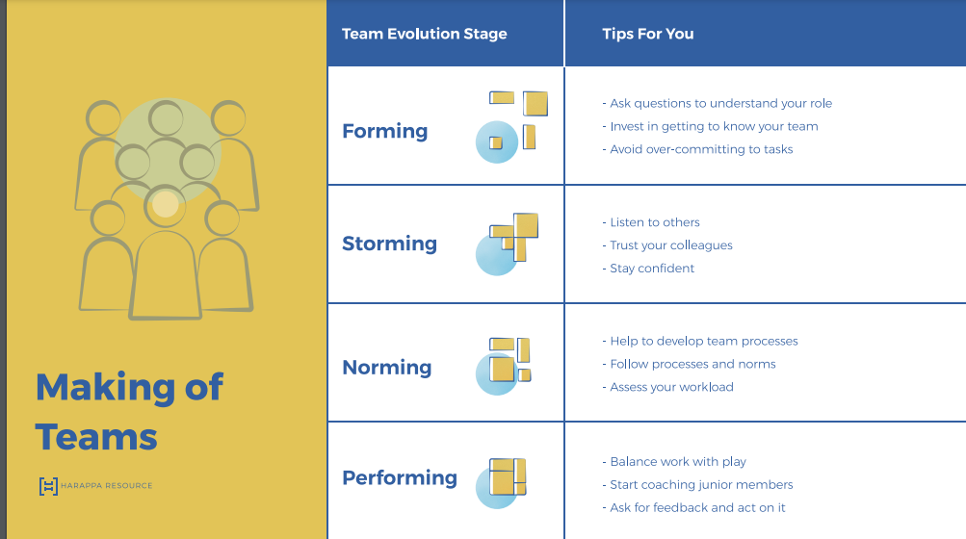

Team Dynamics – trust, social styles model.

Team dynamics are invisible forces that define how people in a team interact with each other, how much they trust and respect each other and how well they get along.

Effective teams have high level trust.

Work style – social style model types – assertiveness, responsiveness.

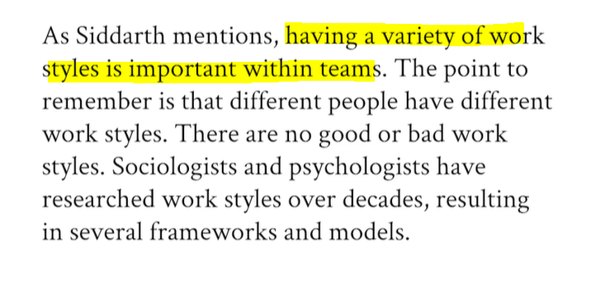

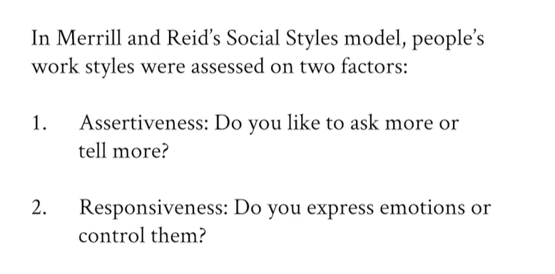

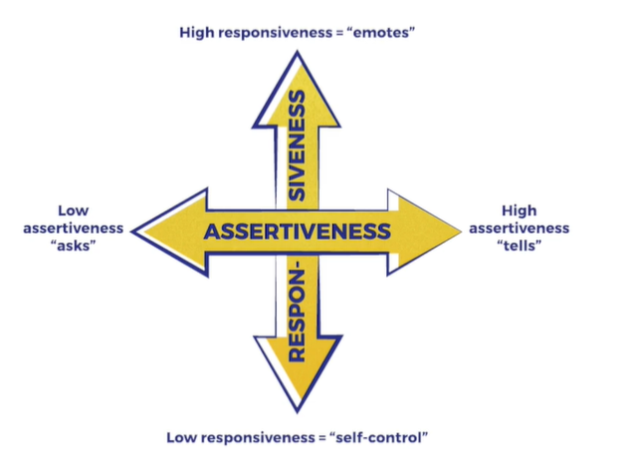

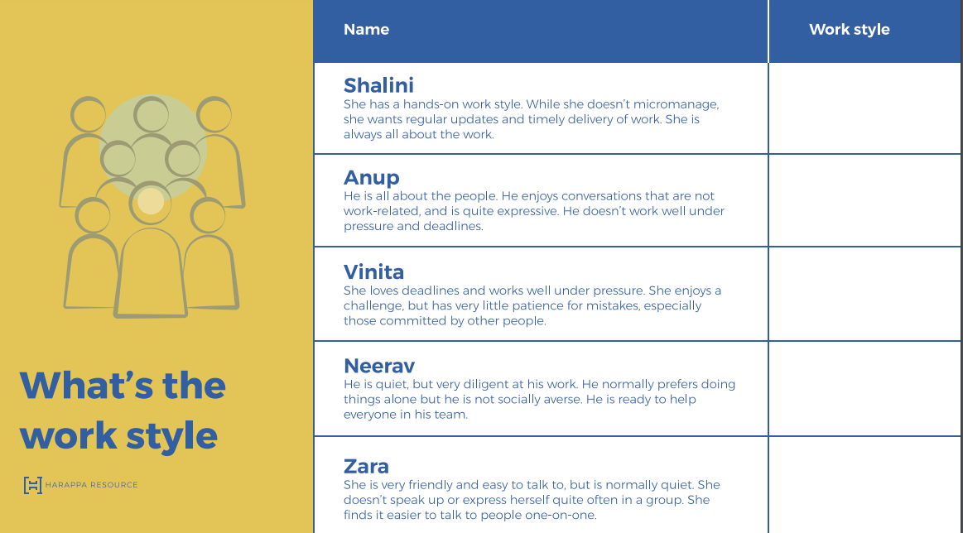

Working with work styles –

Amiable style –

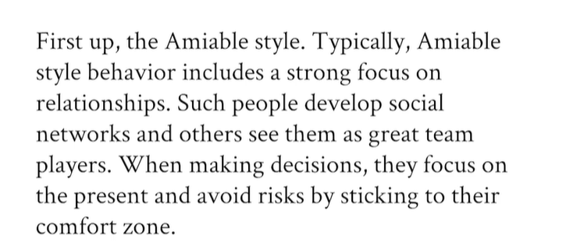

Expression style –

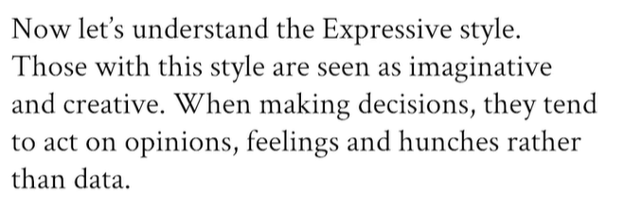

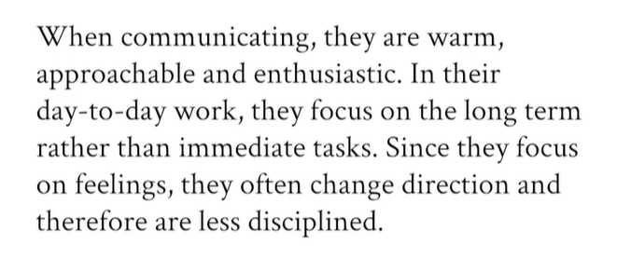

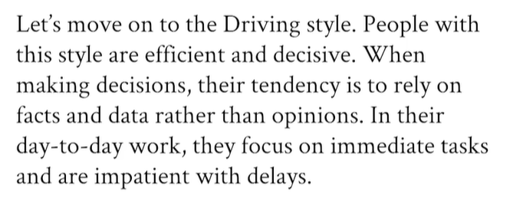

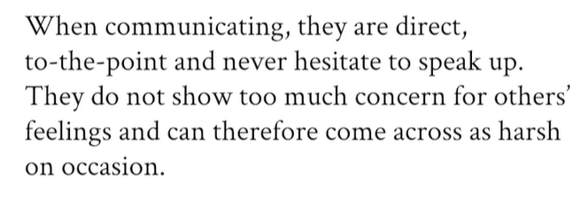

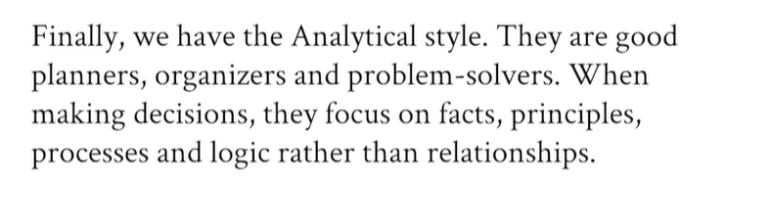

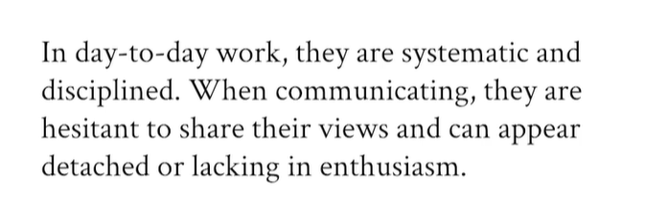

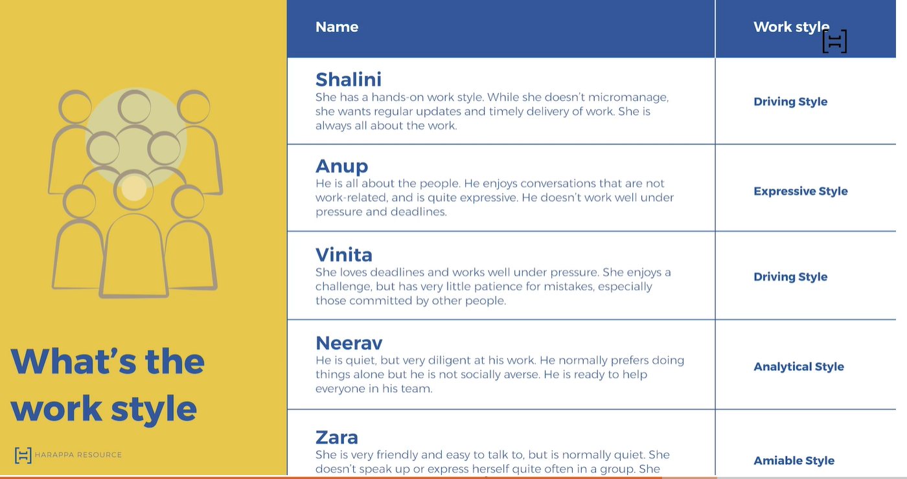

Versatility –

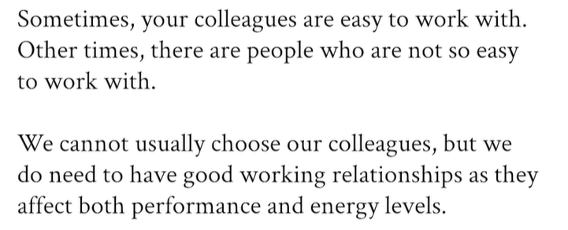

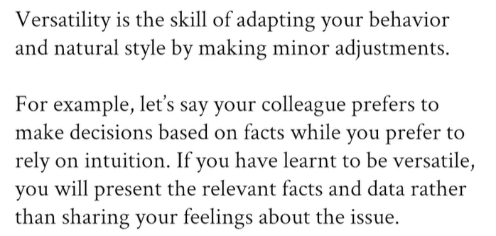

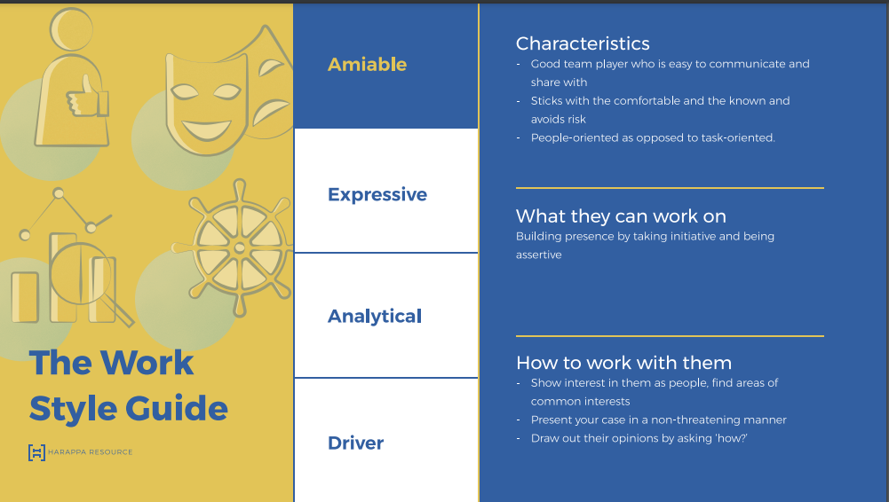

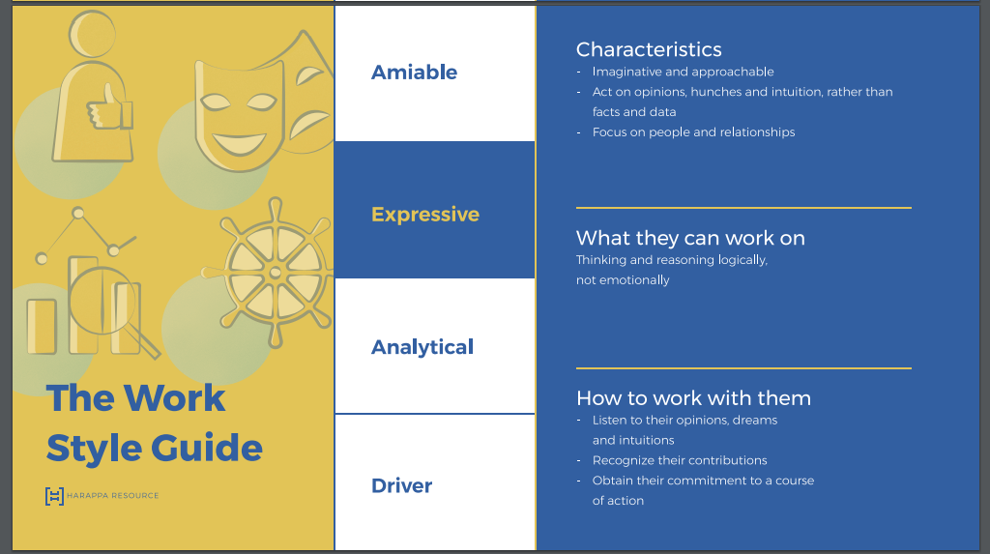

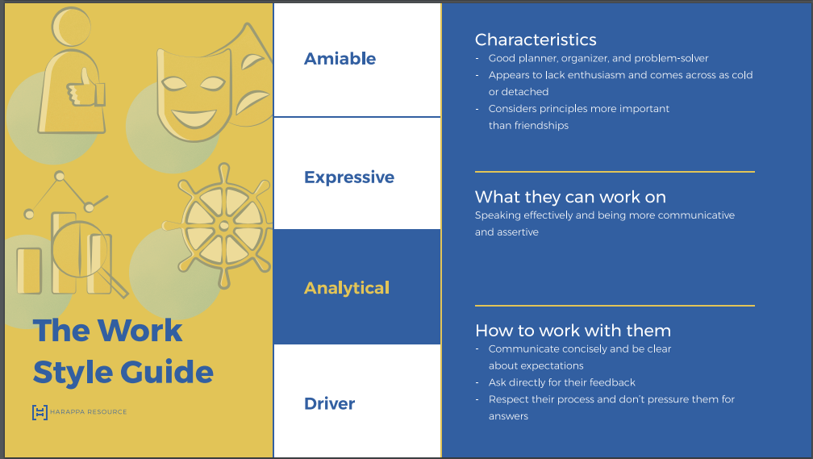

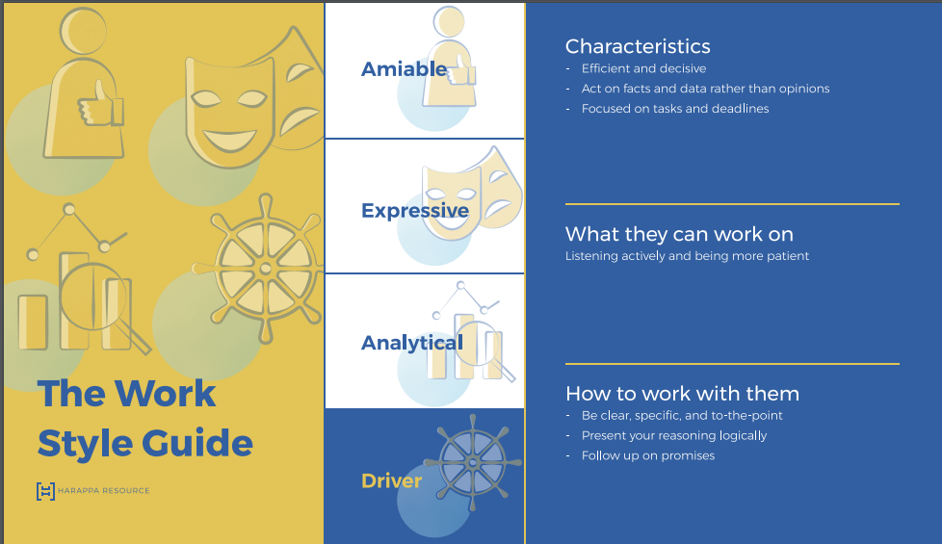

Feedbacks in Teams – To assist performance improvement or change a behaviour.

Below are not a feedback –

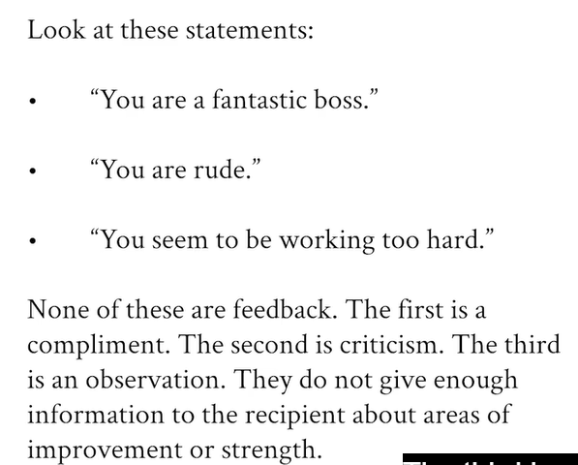

We should not overdo the feedback, it will lead to saturation. Feedback should have three sections – course correct, help someone to do his job better in future and to achieve individual and collective goals.

For in detailed feedback, it should be a video or personal meeting not on email or chat. Also, we should give feedback as soon as possible after that event to avoid fail or memory and immediate recognized.

We should also give a constructive feedback like below, it is focused on action not on the person –

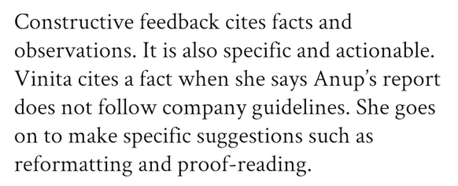

Delivery of feedback – be objective while giving feedback like below

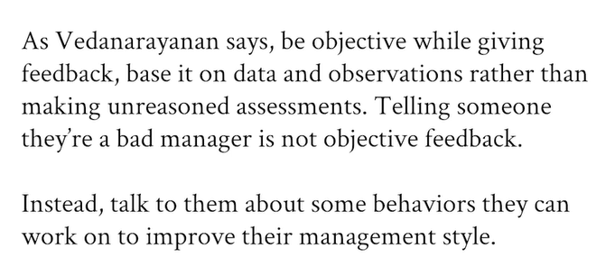

SBIS model for feedback – situation, behaviour, impact and suggestion. Another model is CSS – continue, stop and start. We can even combine the both model.

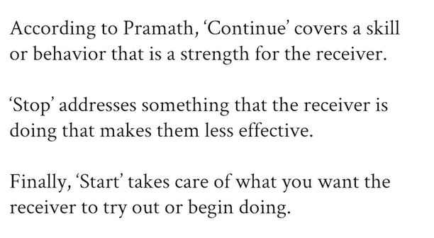

Dealing with reactions –

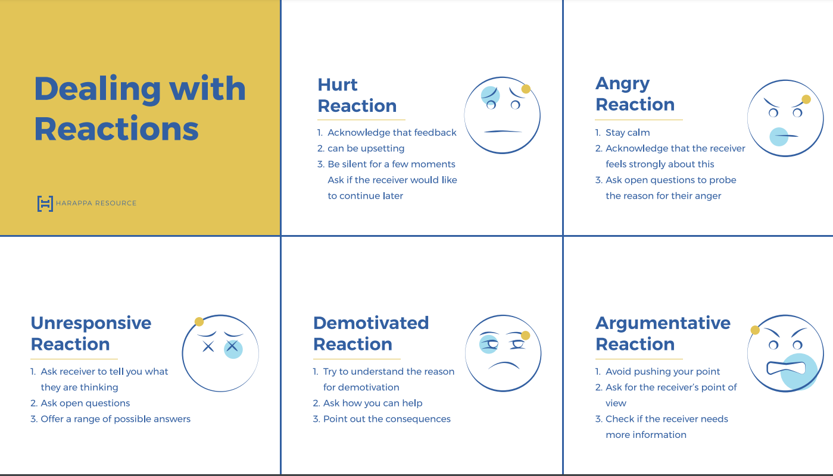

Accept the feedback – don’t be in denial mode, validate and introspect it. LAPSA is the model for receiving the feedback i.e. listen, acknowledge, probe (asking question), summarize, appreciate. Do it in three stages (AVA) – assessing then validating and finally actioning. It is important to not act on feedback immediately, but to assess or evaluate and validate it first.

Manging conflicts in teams – Not all conflict is bad, it can be beneficial. Types – task (functional and can be good for team) or relationship (dysfunctional and bad for team) conflicts. The reason for conflicts is trust, personal workstyle, lack of opportunities.

Behaviour – first and second are bad approaches.

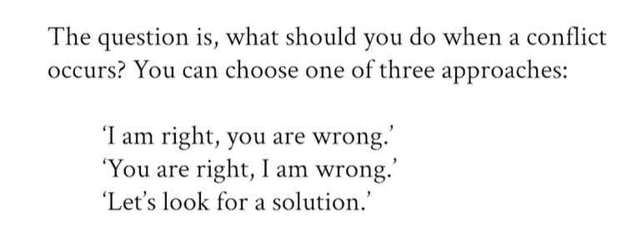

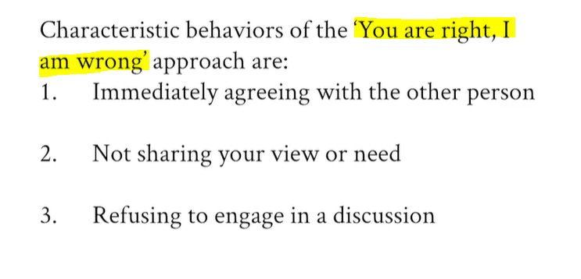

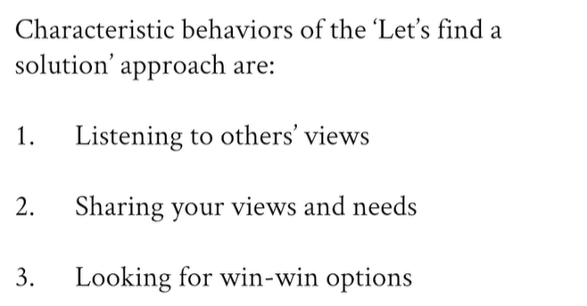

Approach – Dialogue, Escalation and Mediation. (DEM Strategy)

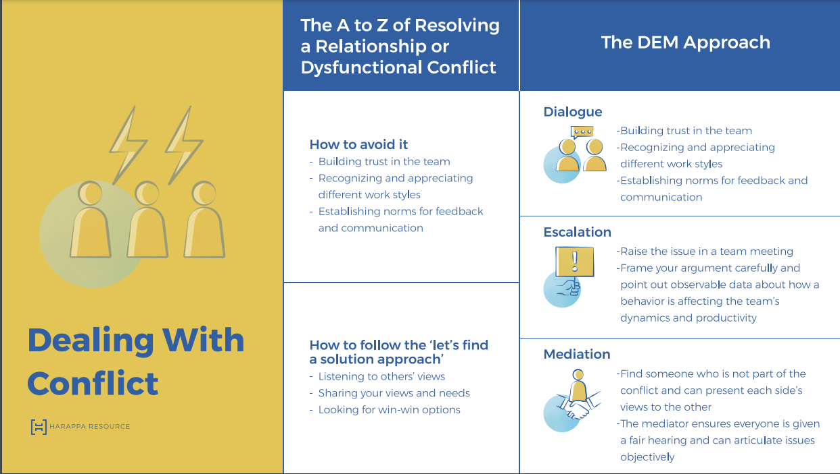

Leading Teams – problem-solving leadership, people leadership, personal leadership. Also, try to bring in expert advise.

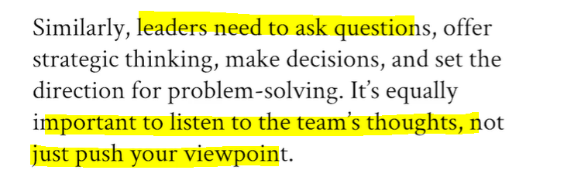

People leadership at its core mans helping your team members be the best version of themselves.

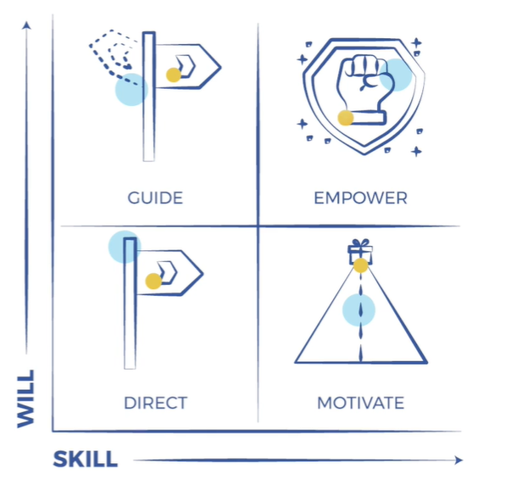

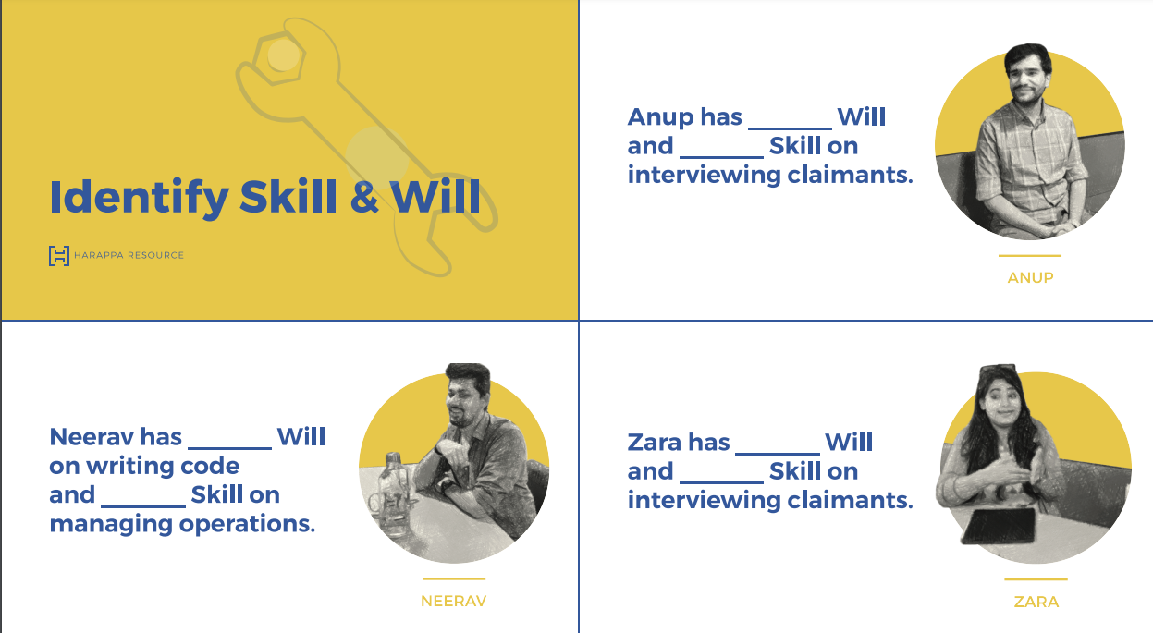

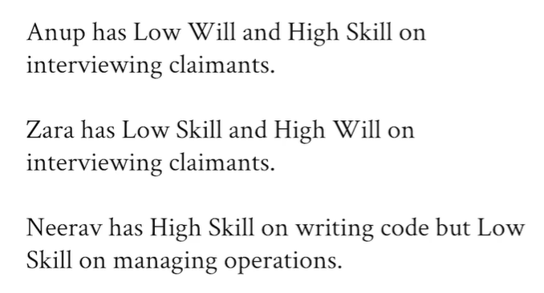

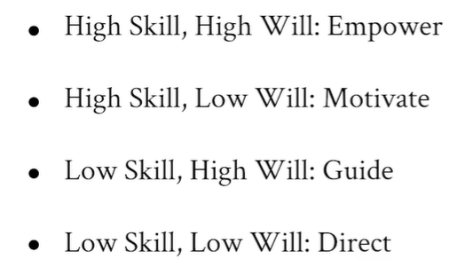

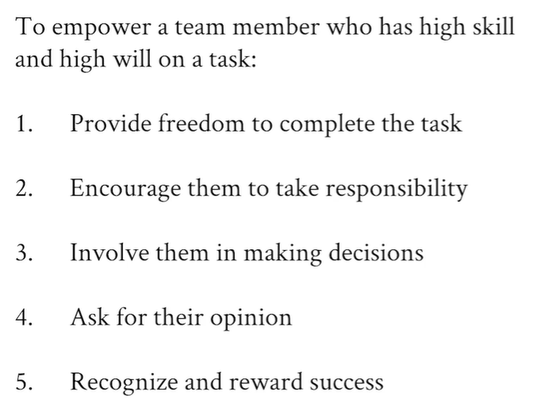

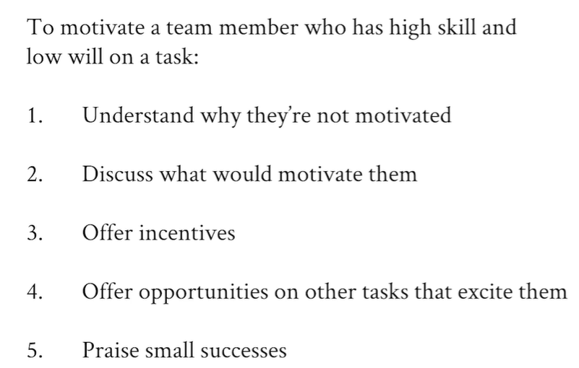

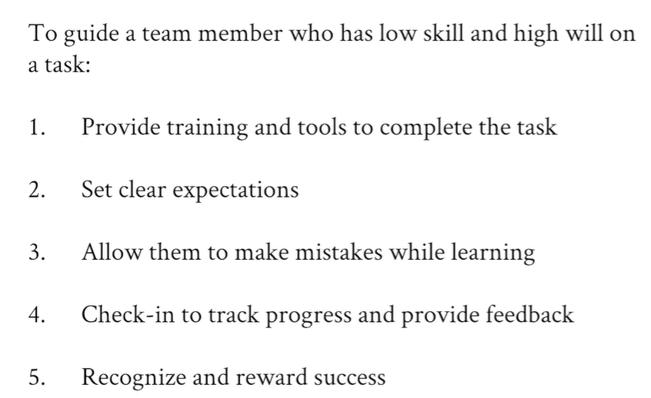

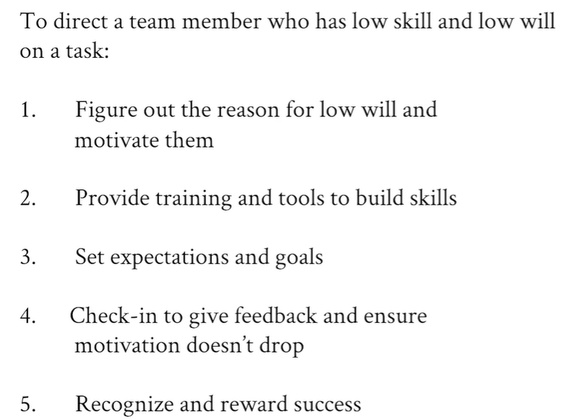

Personal leadership – three aspects – self-awareness, courage, optimism.

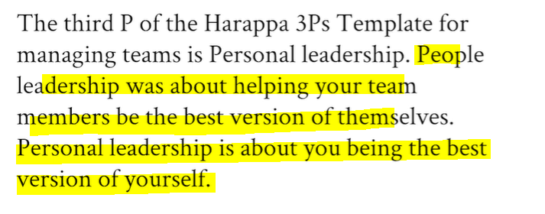

It is okay to say “I don’t know” or “I made a mistake” for good leader.

# Harappa – Building Presence

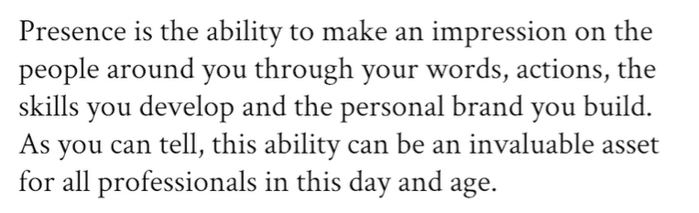

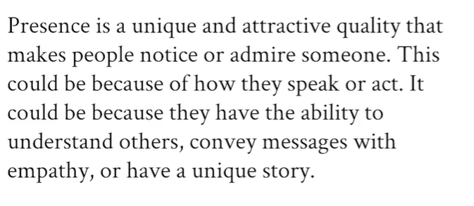

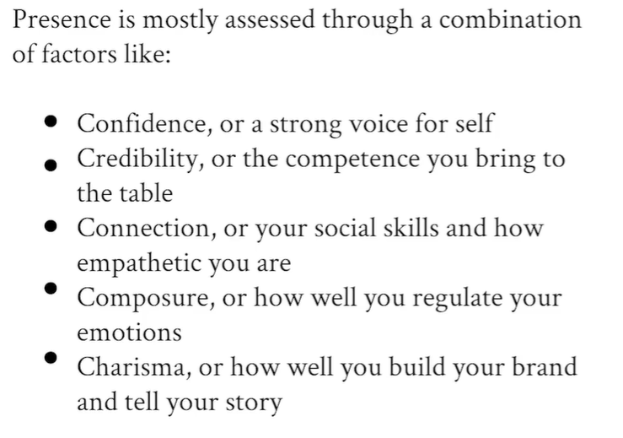

Signature voice –

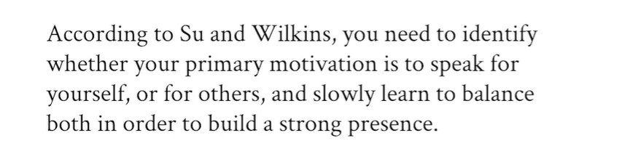

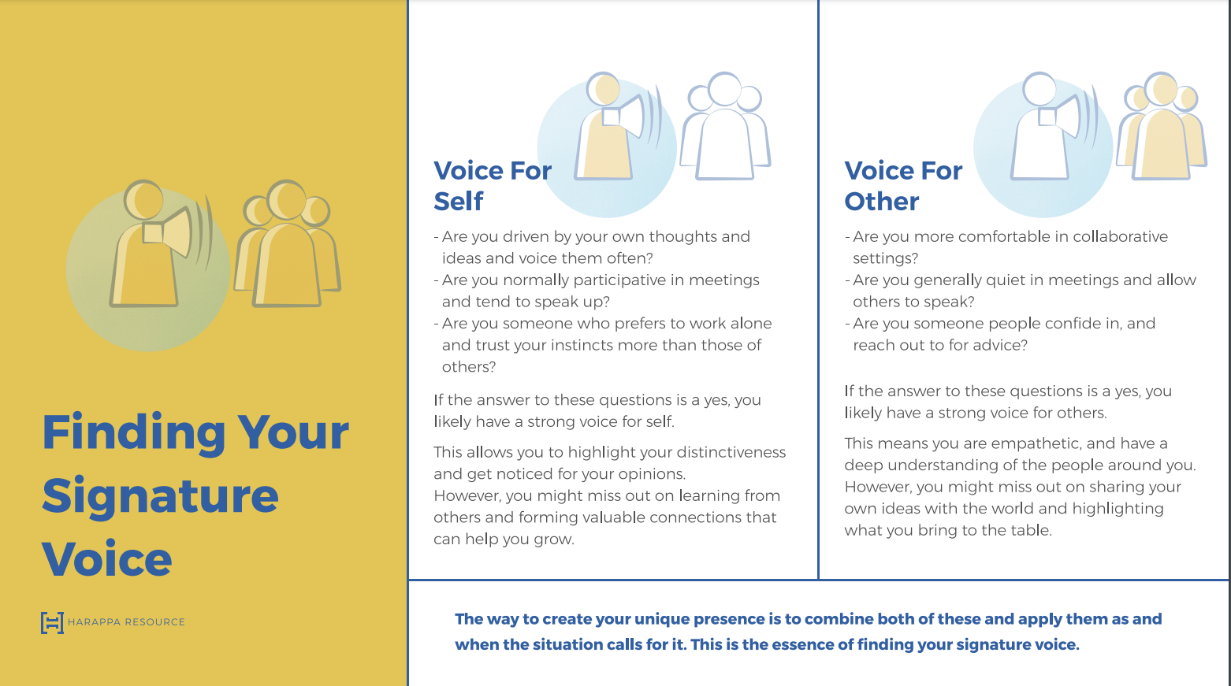

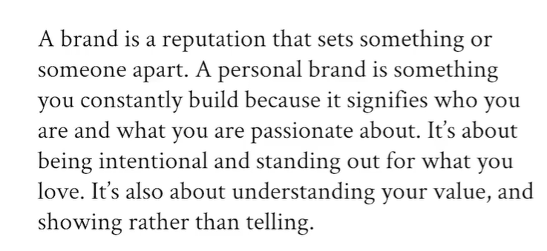

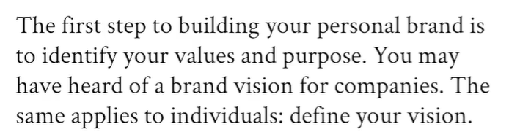

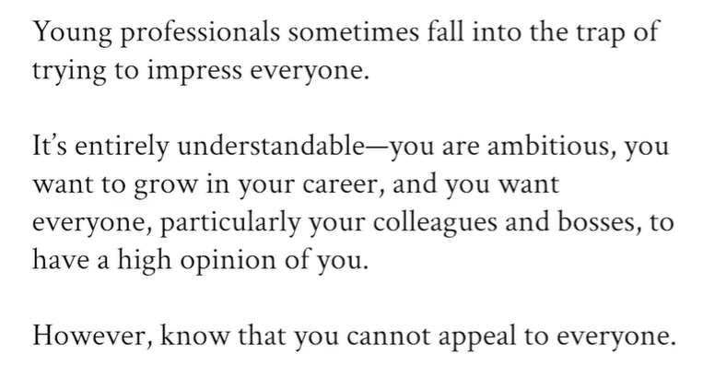

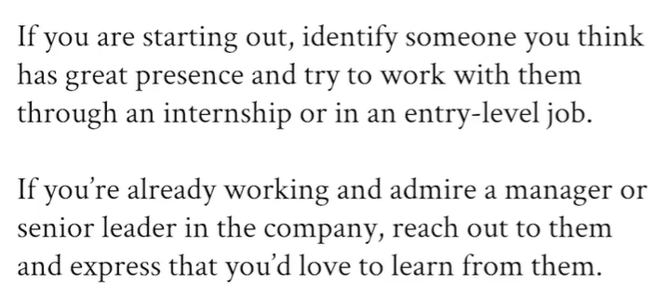

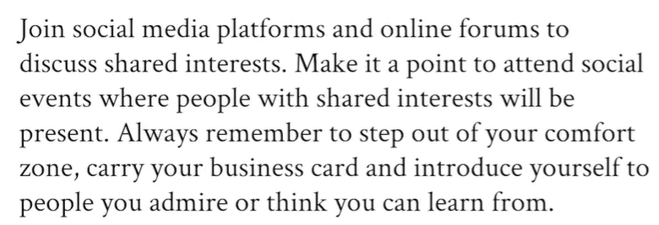

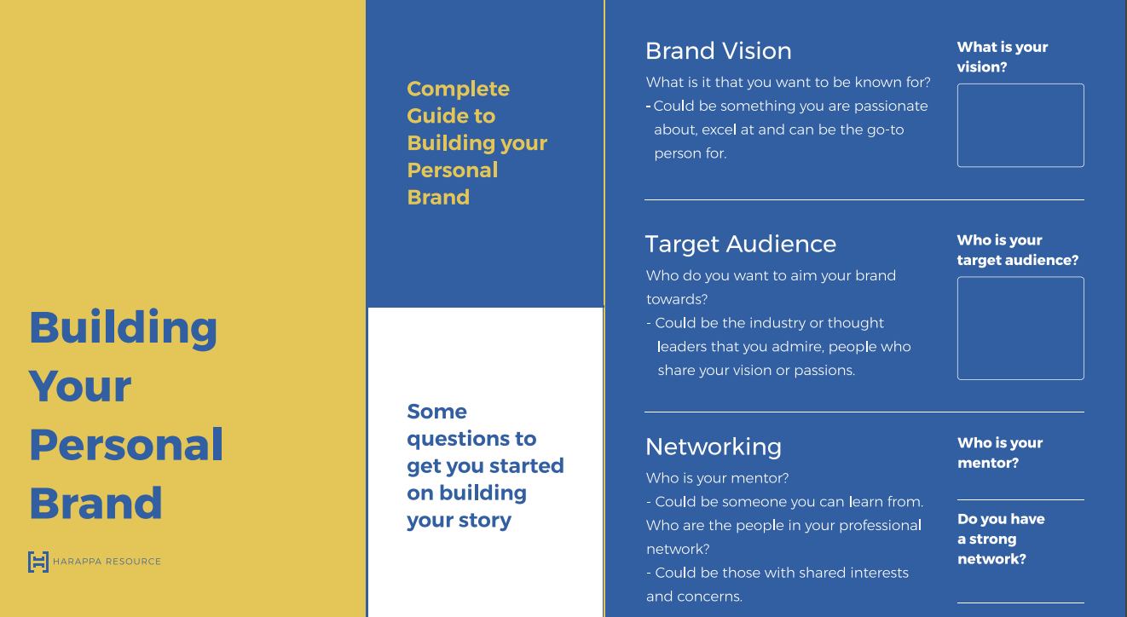

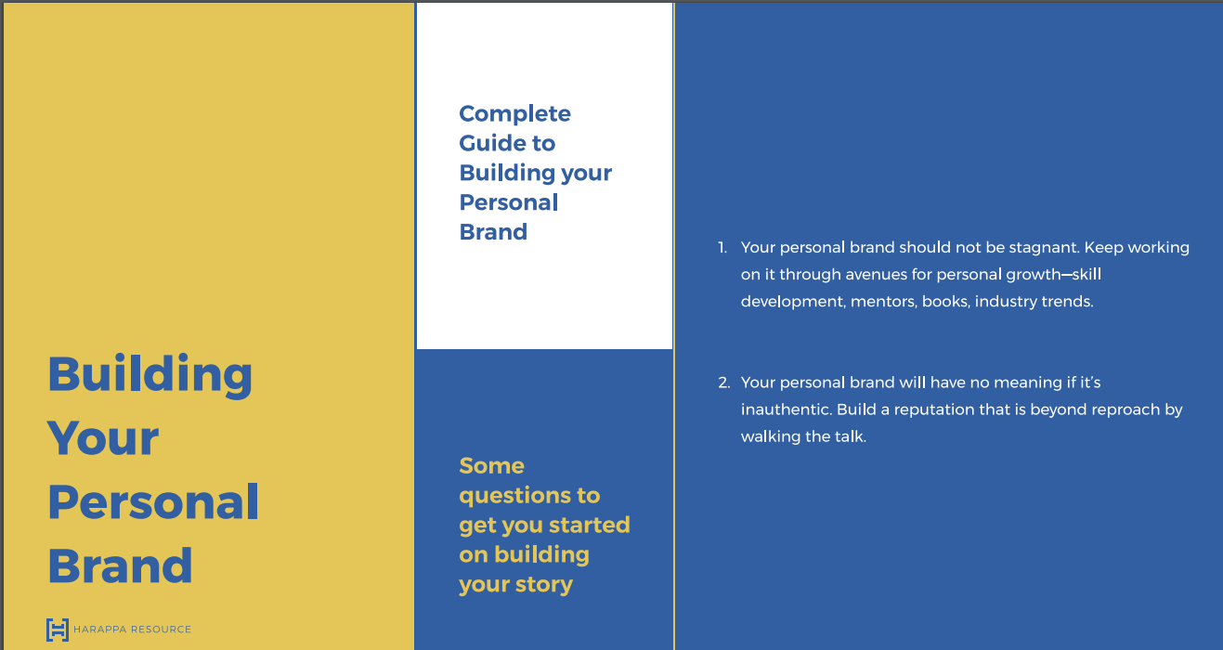

Stages while telling a story –

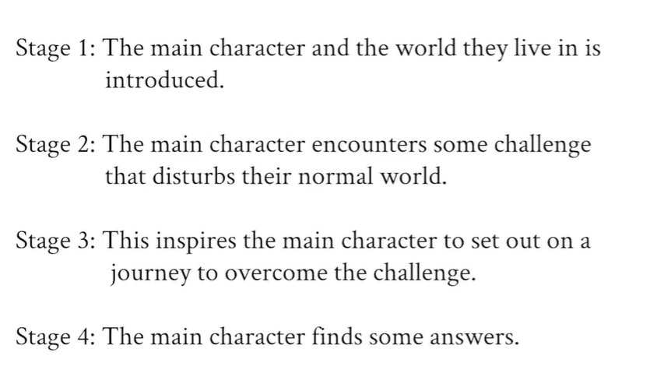

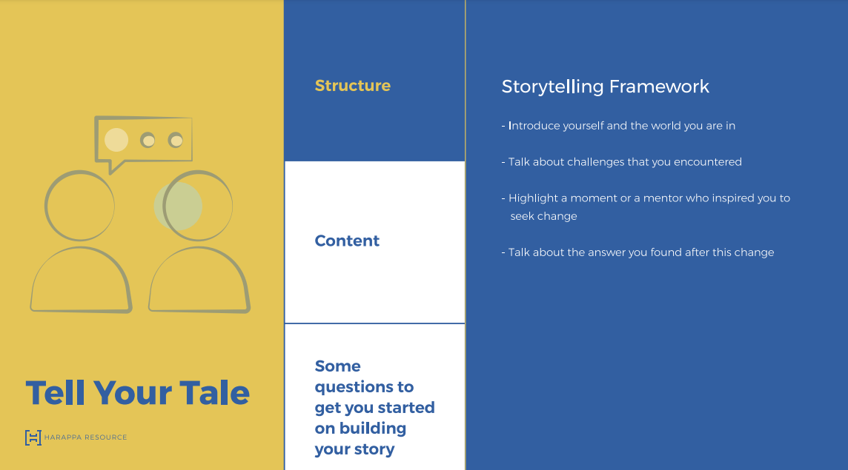

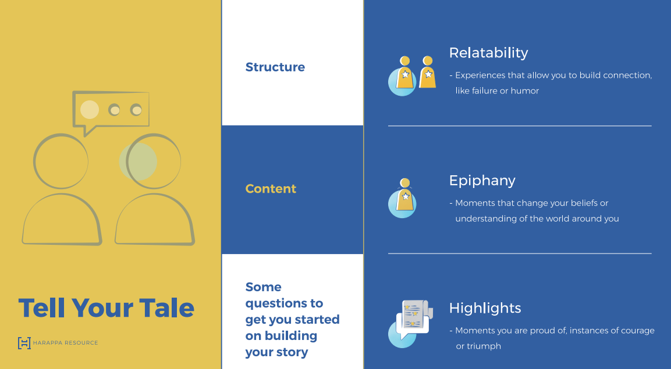

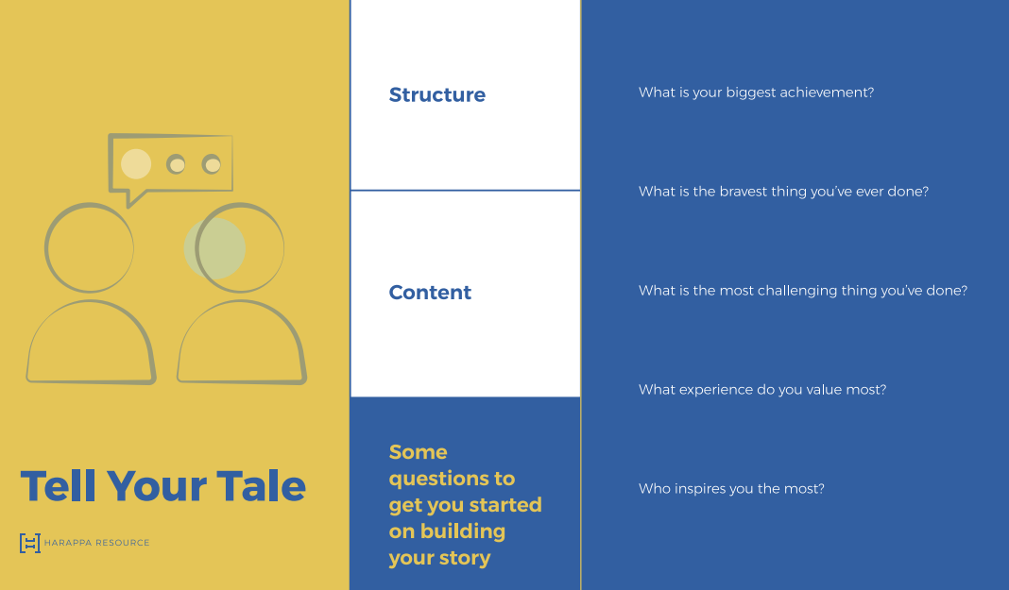

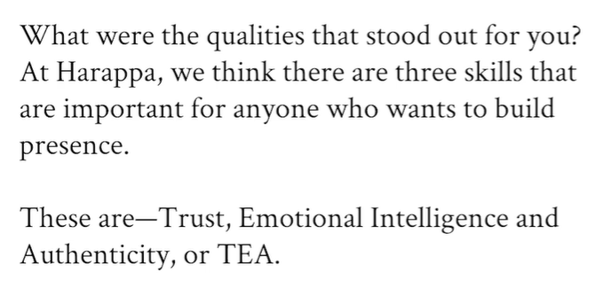

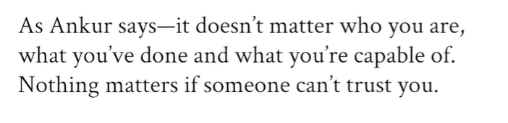

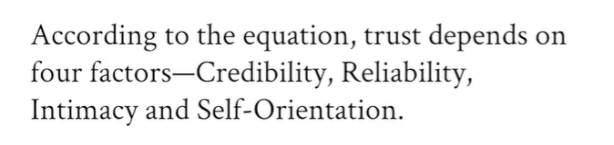

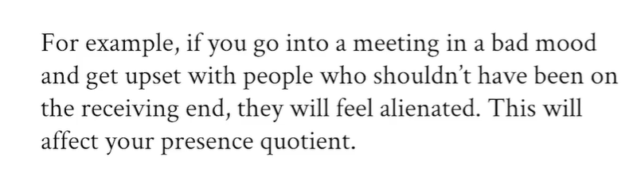

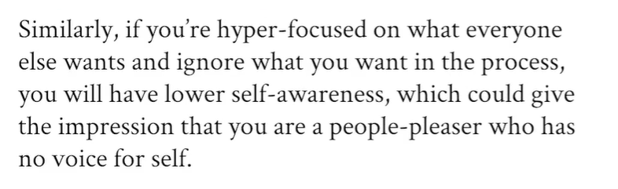

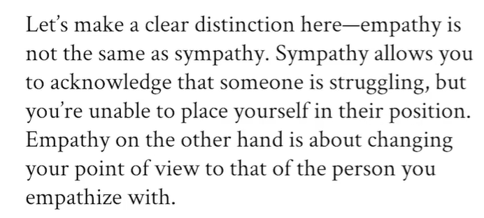

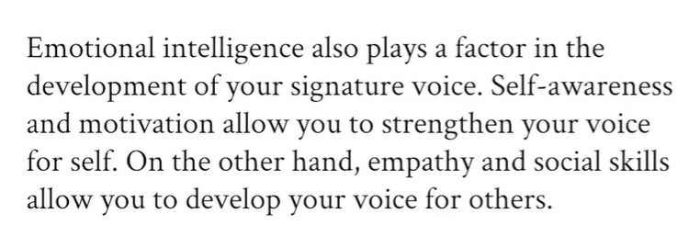

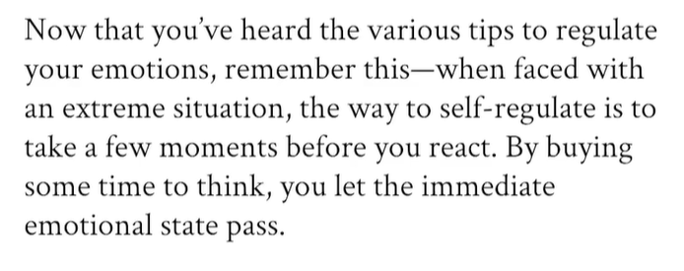

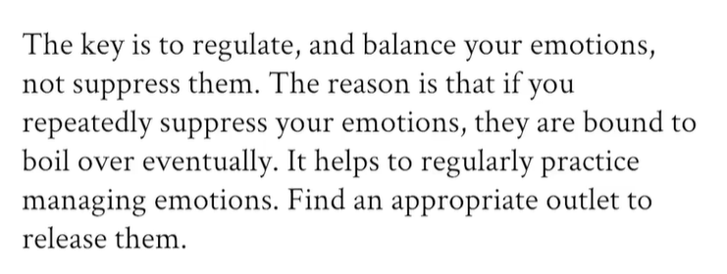

Visual cues –

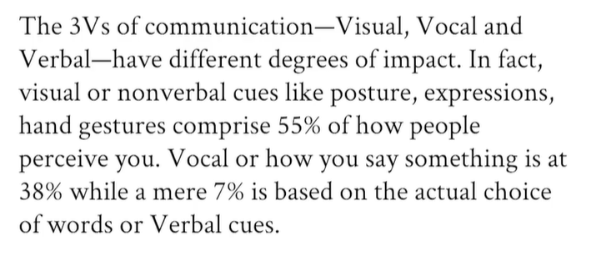

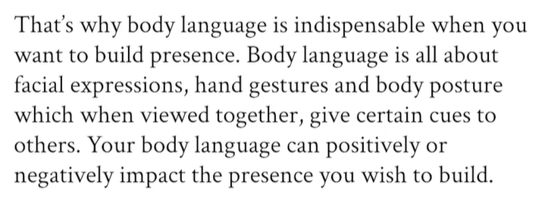

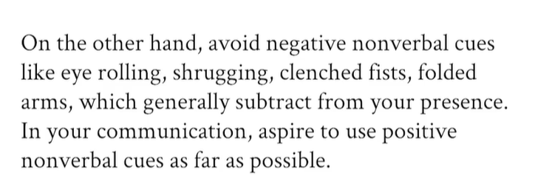

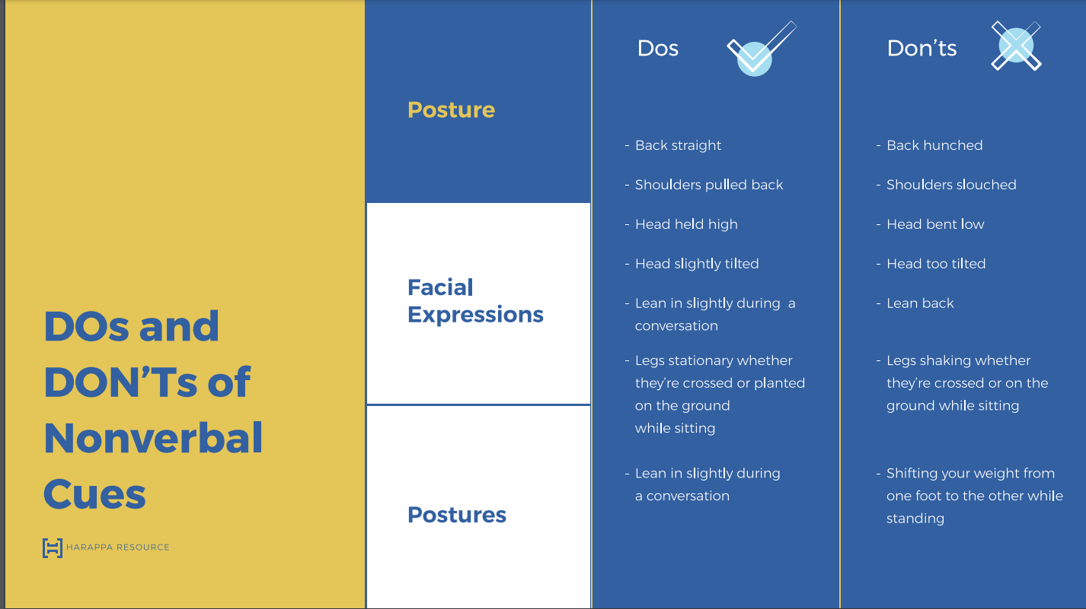

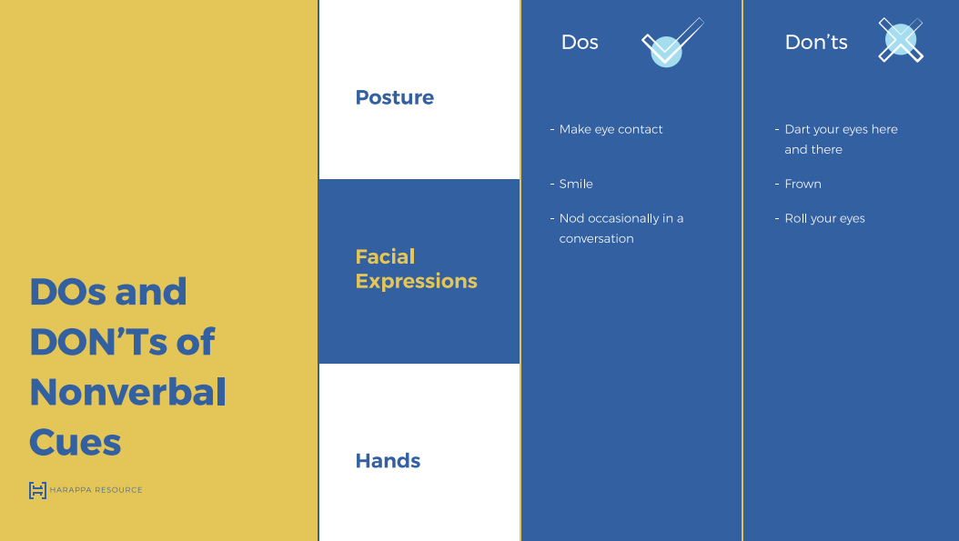

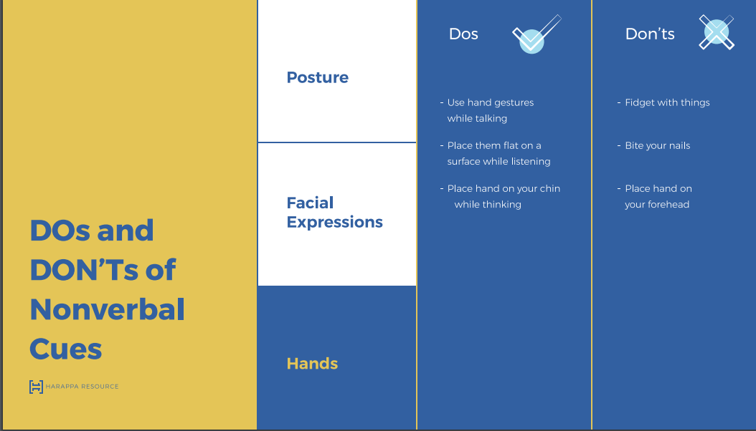

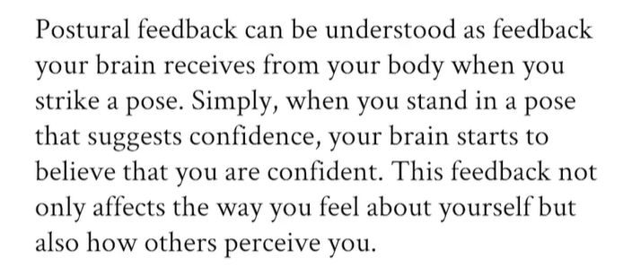

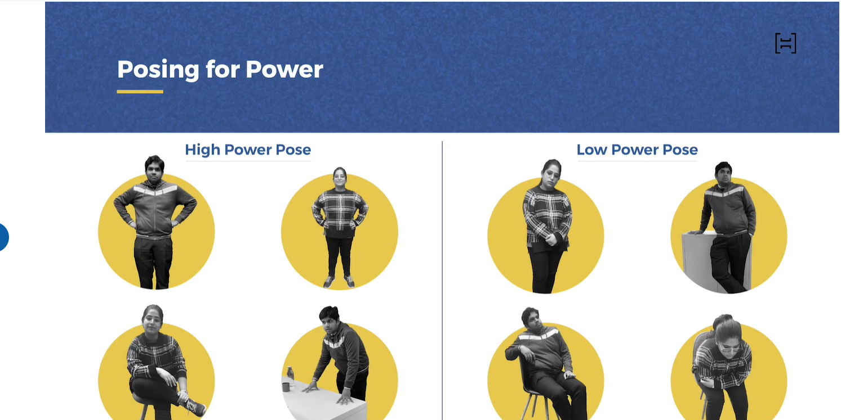

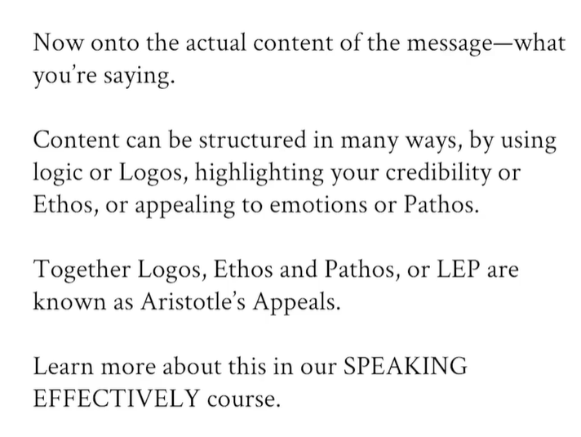

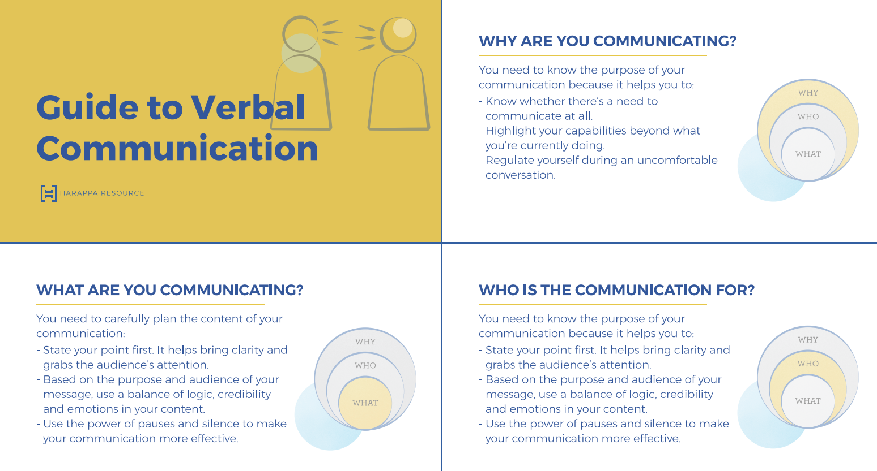

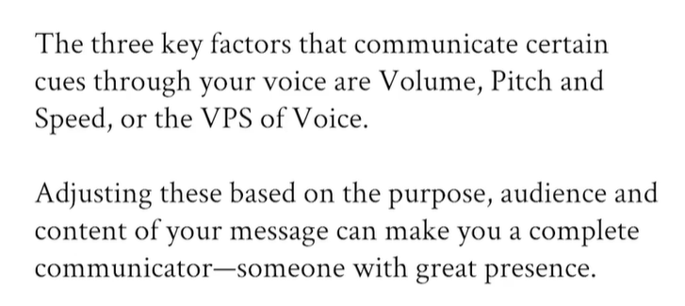

# Becoming a Better Communicator

Don’t use filler words like really, just, so, etc.

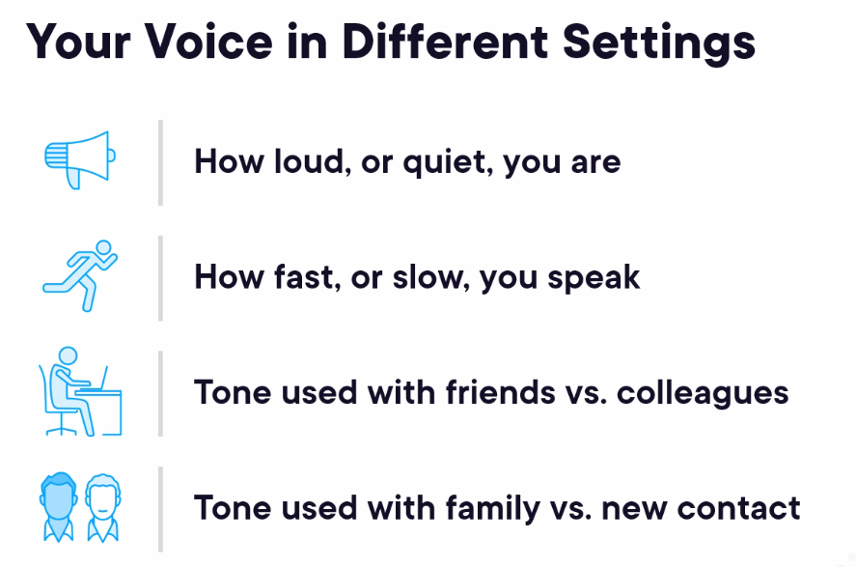

# Writing in the Workplace: Email, Memos, Reports, and Social Messaging

In professional writing, meaning must be inescapably clear.

Some of the flabby phrase which we should avoid –

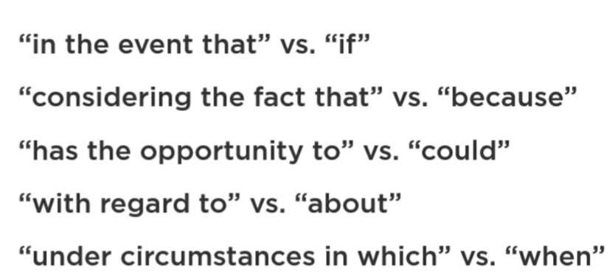

Euphemistic text can also be dishonest –

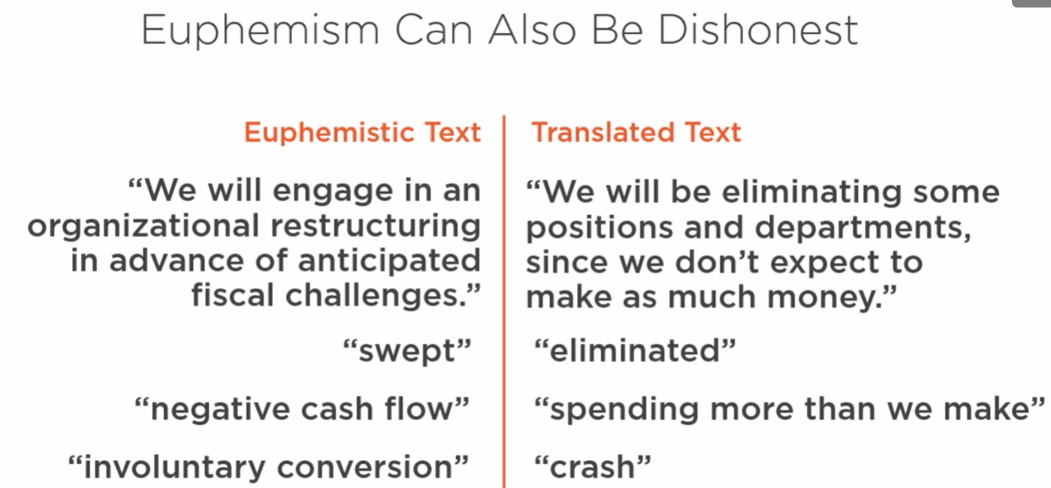

Gobbledygook – intentionally meaningless language – we deliberately use unclear language so that general people don’t understand it and won’t raise any counter question.

Euphemisms and gobbledygook exploit imbalanced power relationships.

Email should have amplification structure – beginning with a declared main idea, followed by supporting details and elaborations, and ending with logistics.

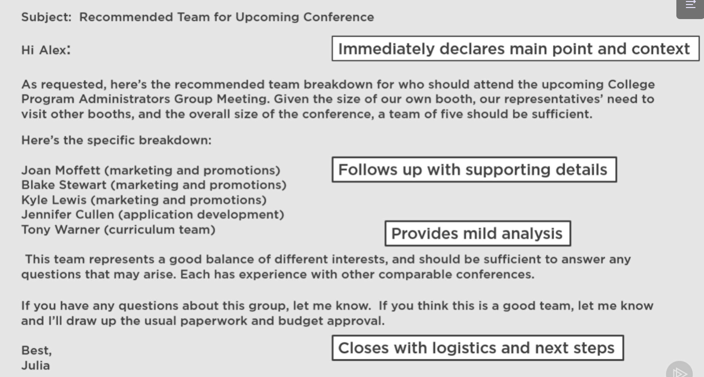

Keep email profession and don’t use below in an email –

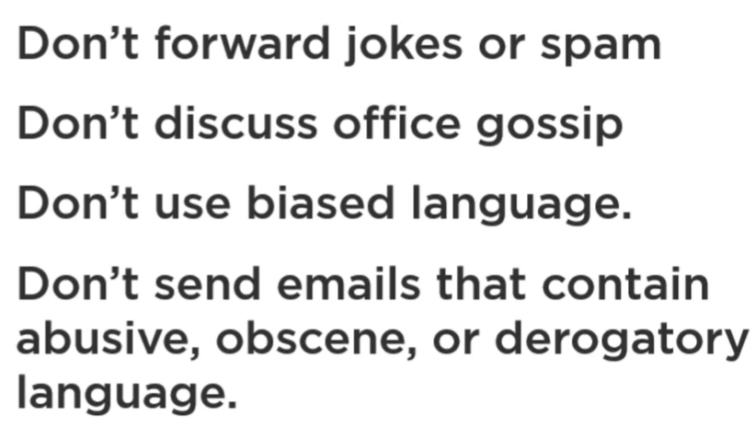

Email is asynchronous communication and instant messaging is synchronous communication.

# Speaking Fundamentals

Tips for creating a demo project –

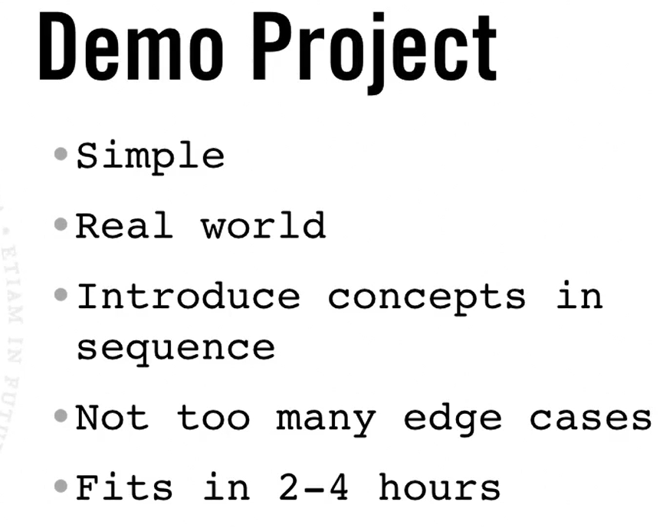

We can also add some notes as a speaker notes to our slide which will be only visible to us while presenting the slides –

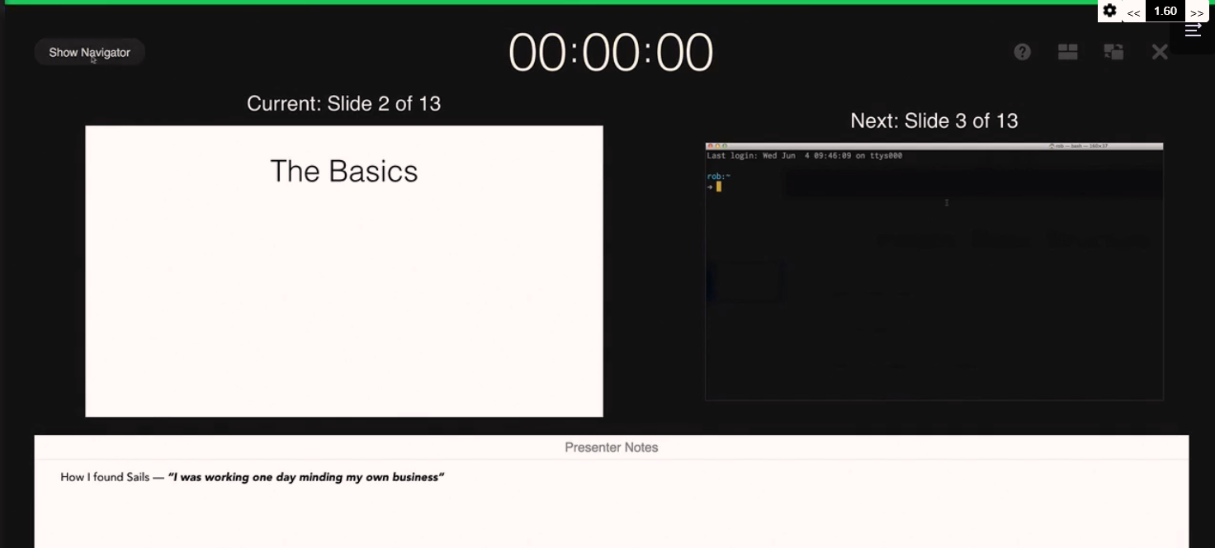

As a backup, have a pre-recorded video of the demos that matters and screenshots, so that we refer them as a slideshow if live demo is failed.

During presentation instead of saying word um… just use silence.

# Better Communication for Better Relationships

Don’t badmouth to your colleagues.

Some communication blunders –

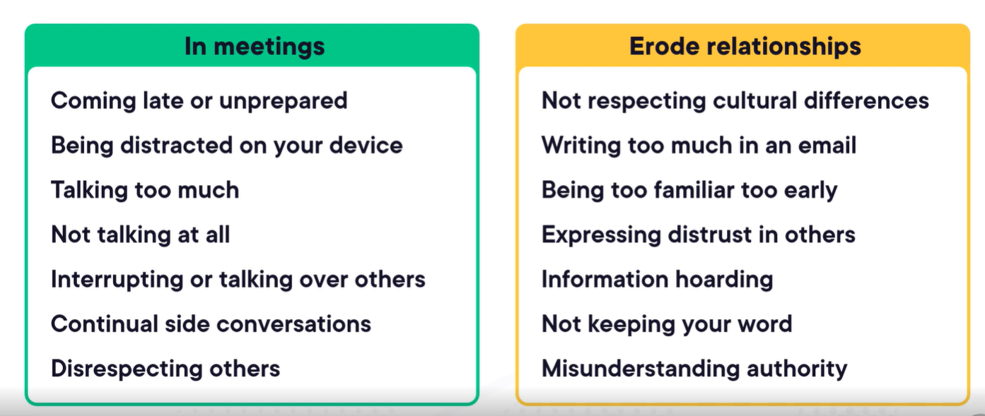

Your word choice is important to the health of your relationships. Don’t use vulgar words, avoid being too casual too early, try to avoid jargon to avoid confusion.

Keep the integrity – be honest, do the right things, avoid cutting corners, take ownership. Keep your word by making realistic commitments.

# [Book] How to win friends and influence people by Dale Carnegie

Animal rewarded for good behavior will learn much more rapidly and retain what it learns far more effectively than an animal punished for bad behavior. Later studies have shown that the same applies to humans.

I will speak ill of no man, and speak all the good I know of everybody.

A dog is the only animal that doesn’t have to work for a living? A hen has to lay eggs, a cow has to give milk, and a canary has to sing. But a dog makes his living by giving you nothing but love.

The expression one wears on one’s face is far more important that the clothes one wears on one’s back.

A man without a smiling face must not open a shop.

The average person is more interested in his or her own name than in all the other names on earth put together. Remember that a person’s name is to that person the sweetest and most important sound in any language.

Ask questions that other persons will enjoy answering. Be a good listener. Encourage others to talk about themselves.

You can’t win an argument. You can’t because if you lose it, you lose it and if you win it, you lose it. What about him? You have made him feel inferior. You have hurt his pride.

The only wat to get the best of an argument is to avoid it.

If you are wrong, admit it quickly and emphatically.

Socratic method, based upon getting a “yes, yes” response. Ask questions with which his opponent would have to agree.

If you want enemies, excel your friends; but if you want friends, let your friends excel you.

When we have some time to chat, I ask them to share their joys with me, and I only mention my achievements when they ask.

The truth has to be made vivid, interesting, dramatic. You have to use showmanship. The movies do it. Television does it. And you will have to do it if you want attention.

Beginning with praise is like the dentist who begins his work with Novocain. The patient still gets a drilling, but the Novocain is pain killing. A leader will begin with praise and honest appreciation.

I have no right to say or do anything that diminishes a man in his own eyes. What matters is not what I think of him, but what he thinks of himself. Hurting a man in his dignity is a crime.

# PowerPoint 2021 Pro

Adding screen tip text –

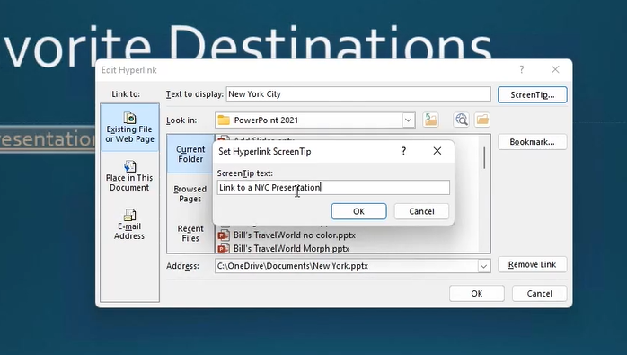

We can also use different Morph transitions for animation –

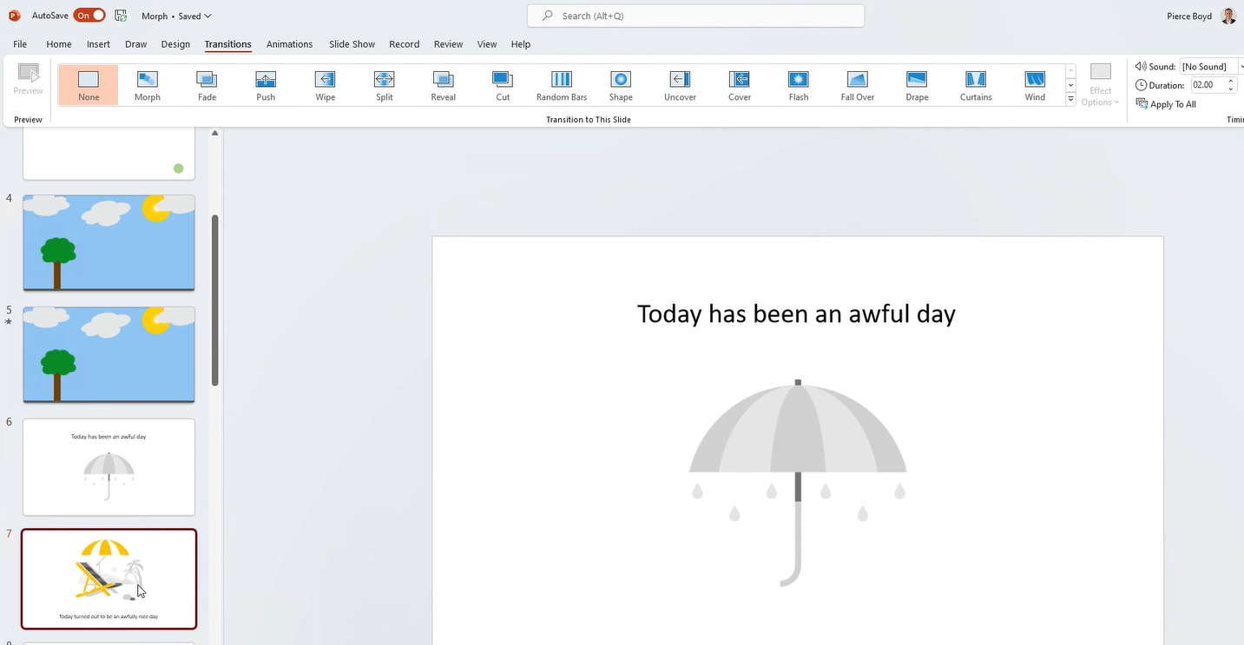

We can use grid lines to create more precise layouts –

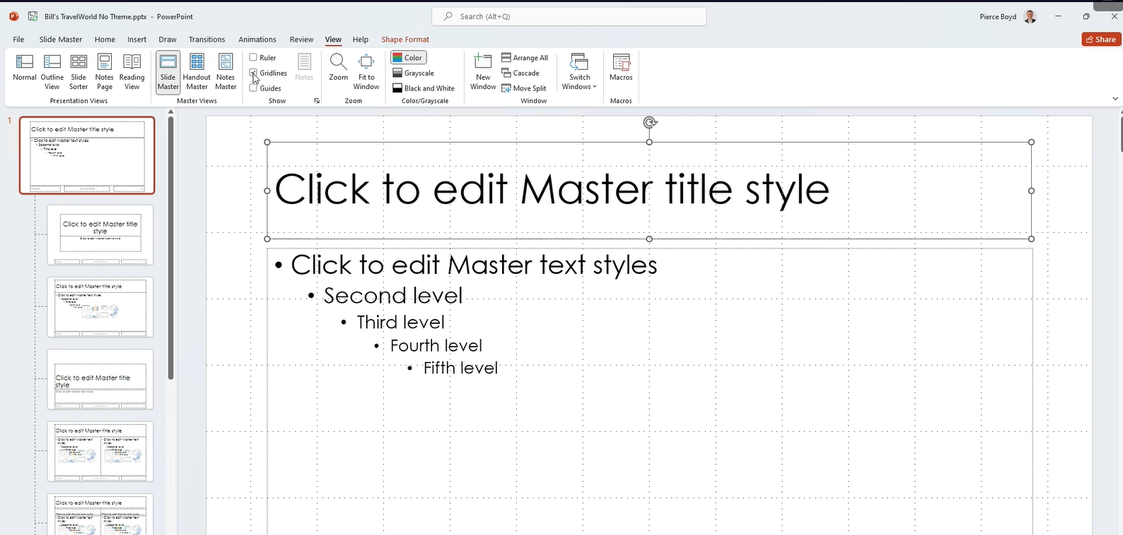

From insert pictures options, we can also insert icons on the slides –

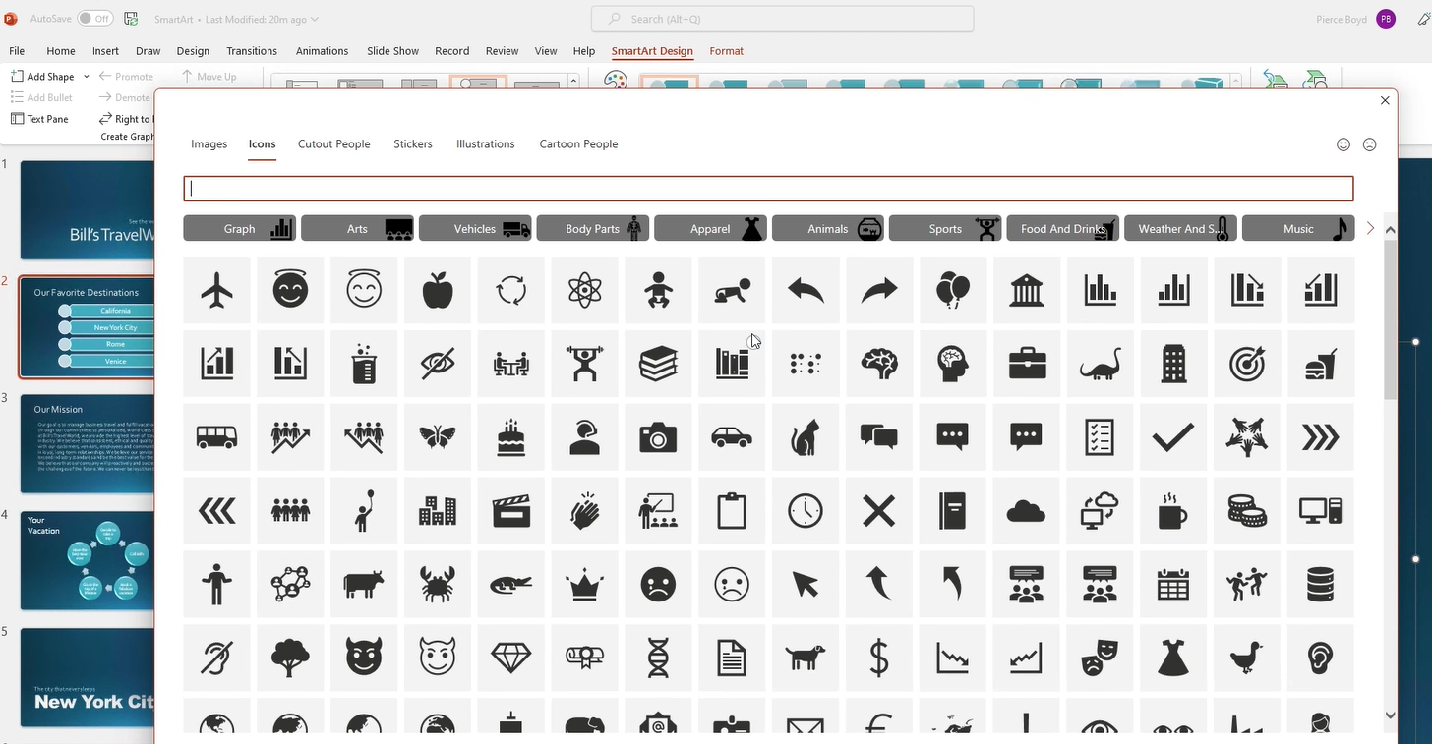

Instead of individually applying the colors, we can choose a color scheme –

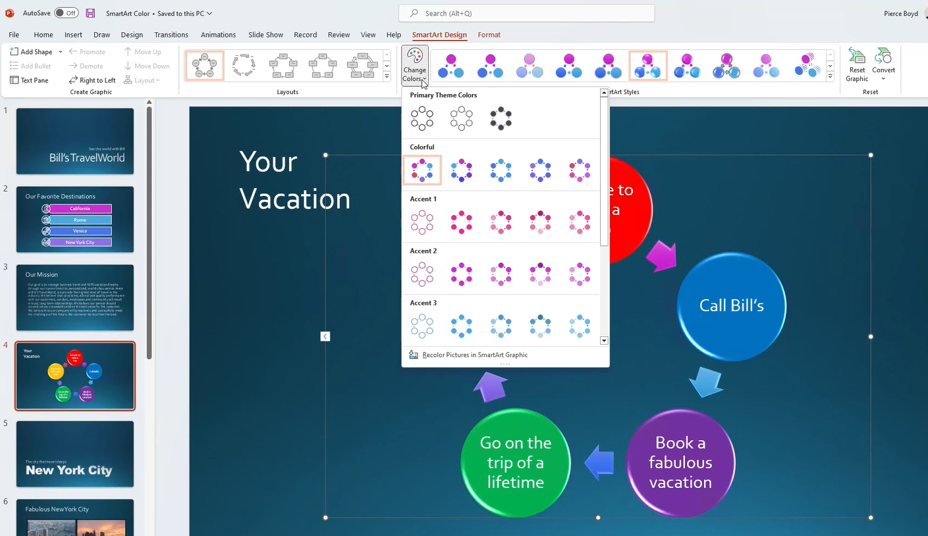

We can add a new shape item to the existing shape collection –

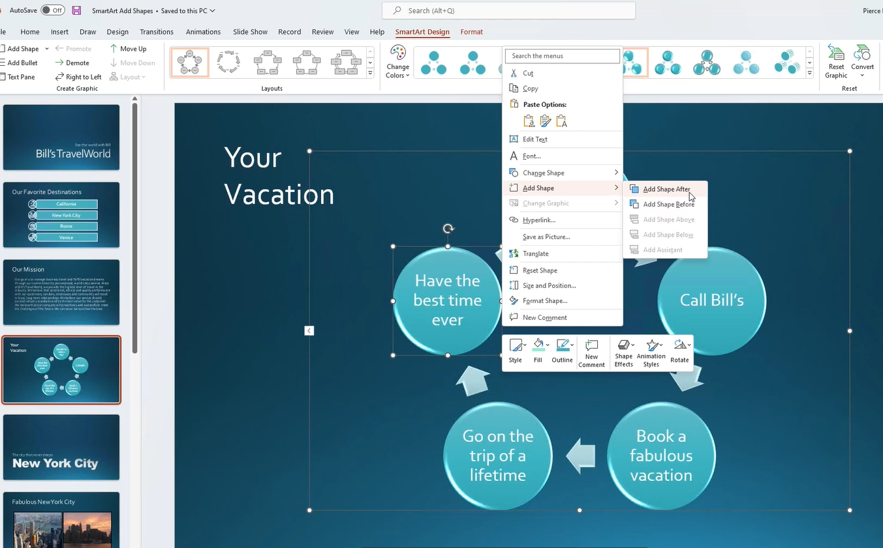

We can add different types of smart art graphics shapes –

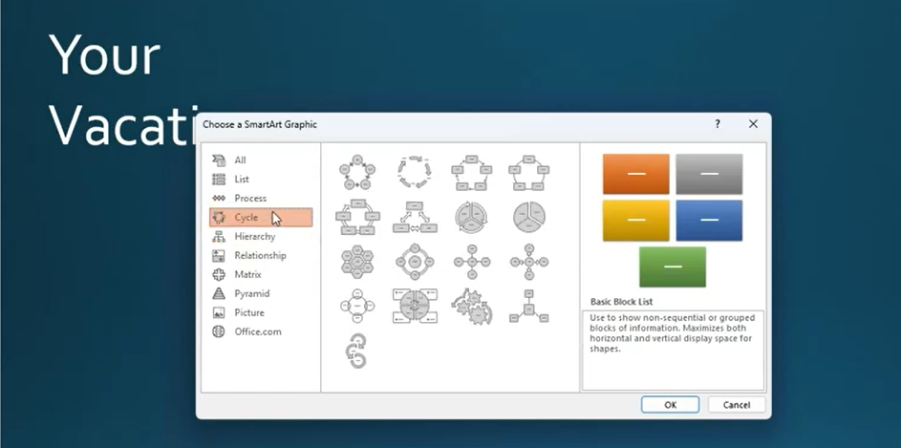

We can use reuse slides options to open the different slide into preview pane to reuse the required slides.

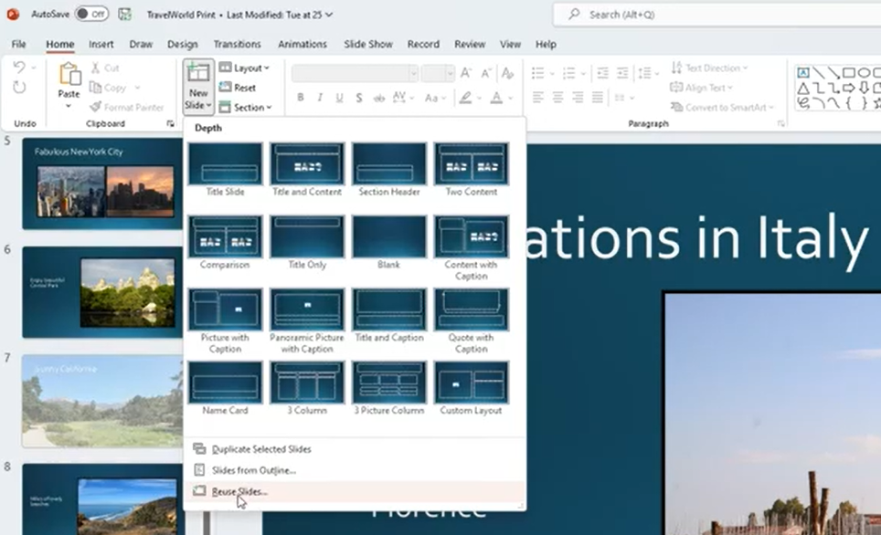

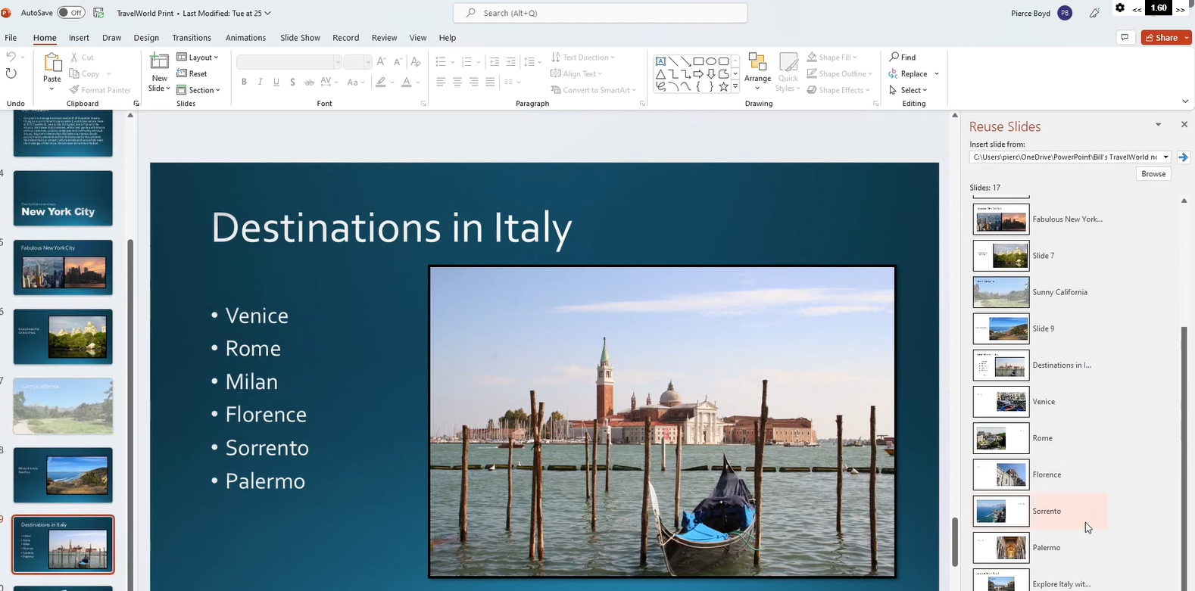

Use the presenter slide mode which will also shows the notes for the current slide –

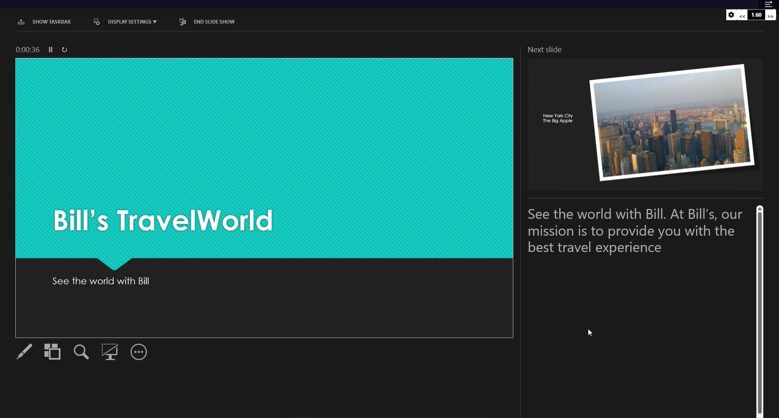

We can also use other options like zoom, edit, gallery view, black out slide show in that presenter slide mode –

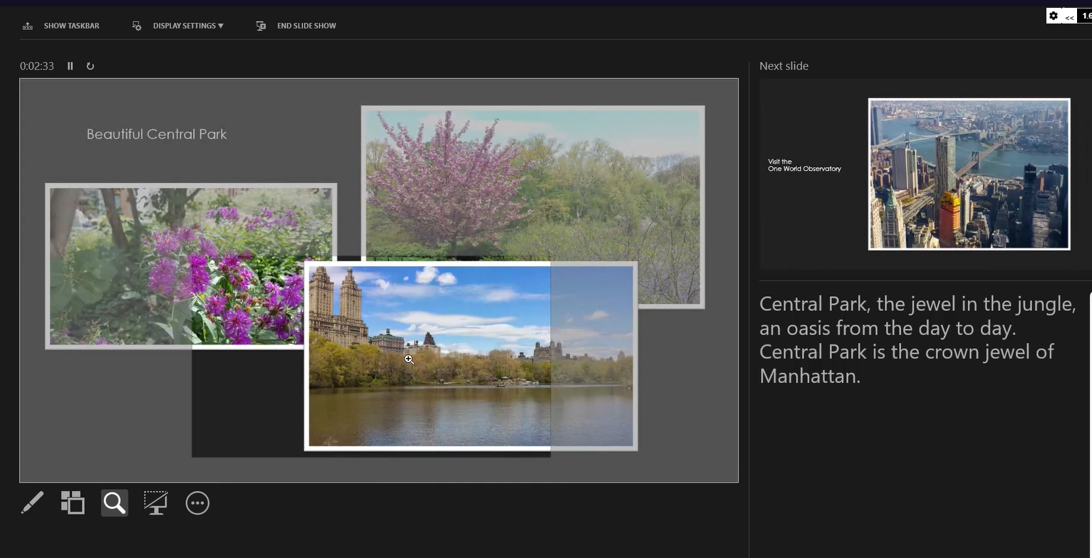

We can also create a animated GIF from the presentation slides –

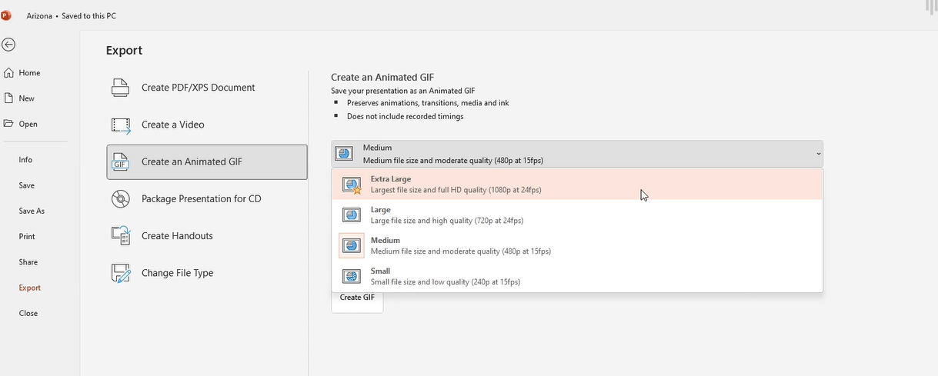

We can also check and fix issues related to accessibility, compatibility or hidden properties in slides –

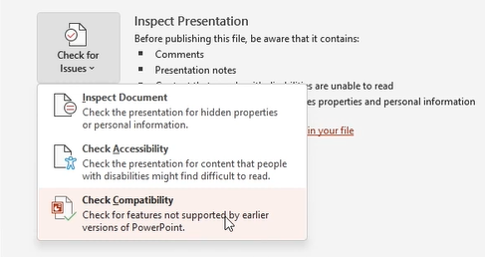

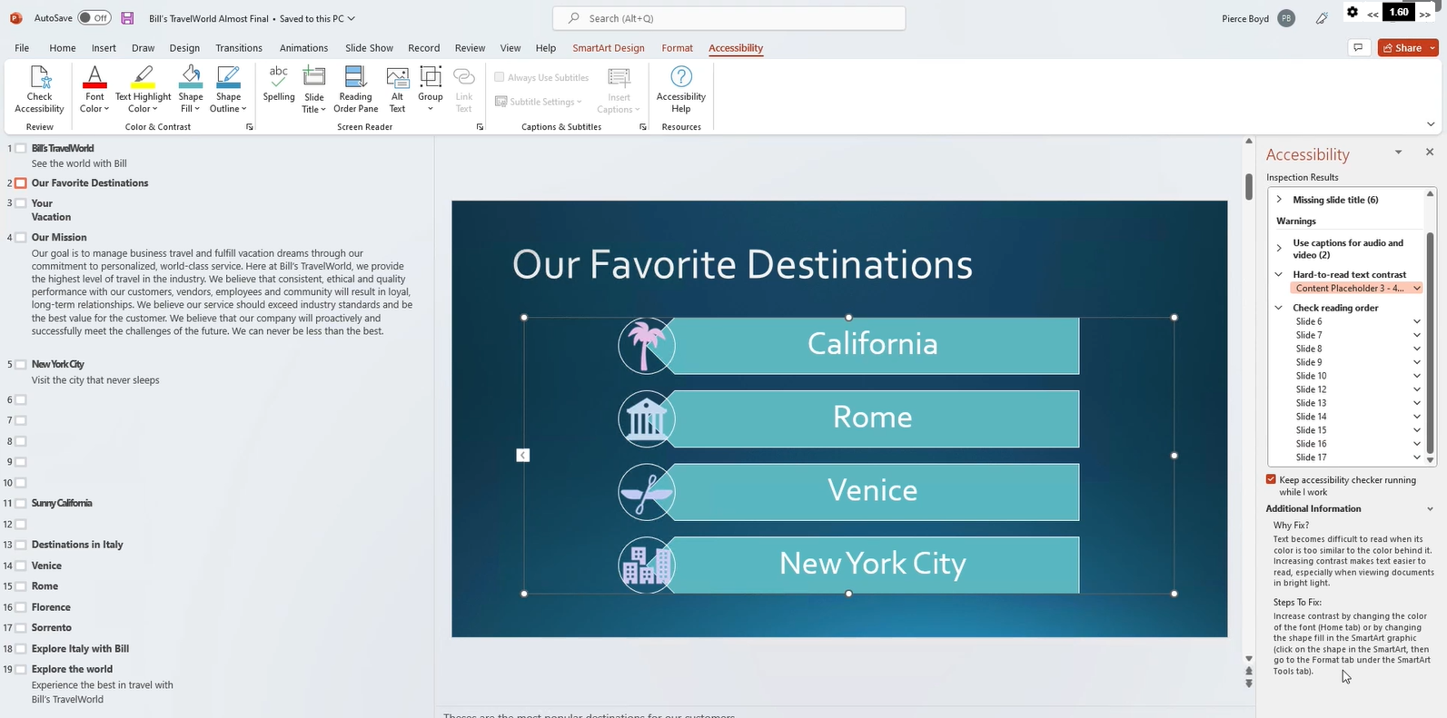

# Harappa - Developing A Problem Solving Mindset

To solve a problem first get to the root of the problem by listening to multiple perspectives and different stakeholders.

Types of problems – adaptive, technical, blended.

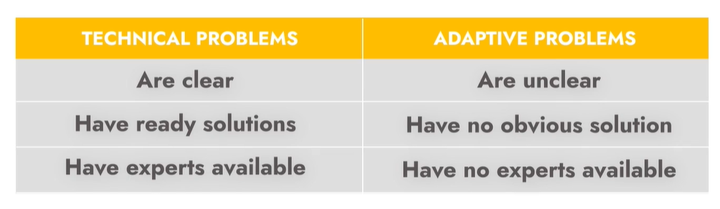

As per Albert Einstein –

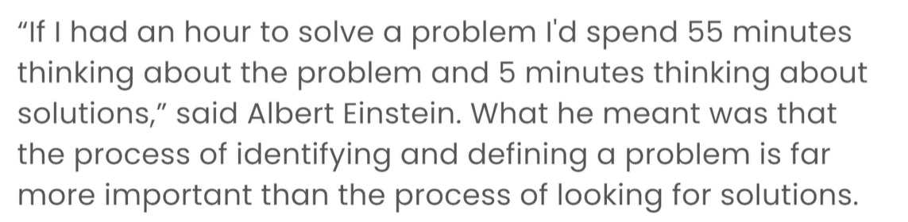

We should make SMART problem statement –

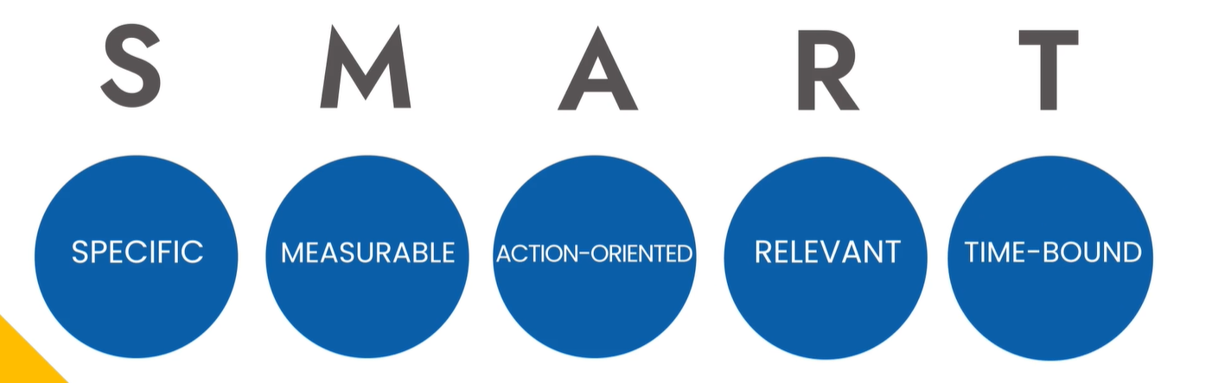

Problem definition framework –

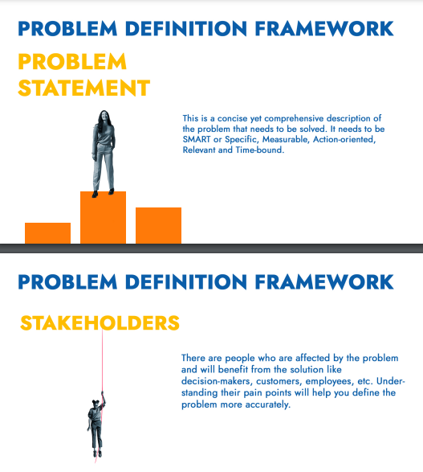

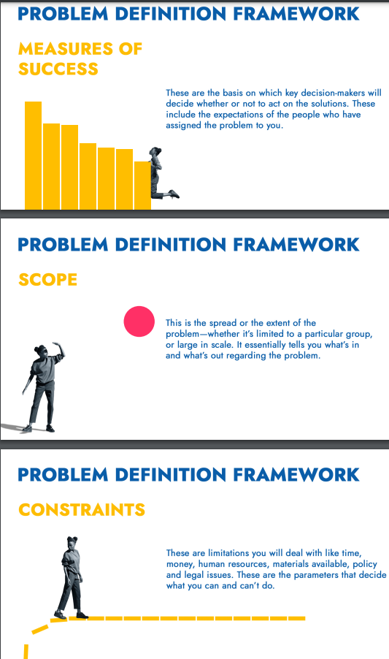

Problem logic tree –

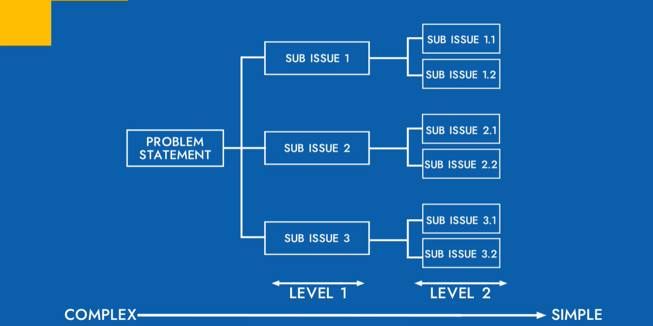

MECE – It will help while structuring problems. Starting with CE will help as in listing all possible concerns from every possible stakeholder.

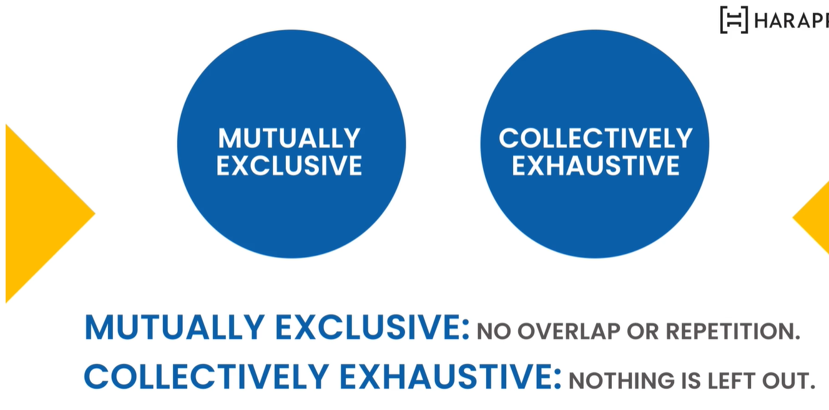

Harappa PICK framework –

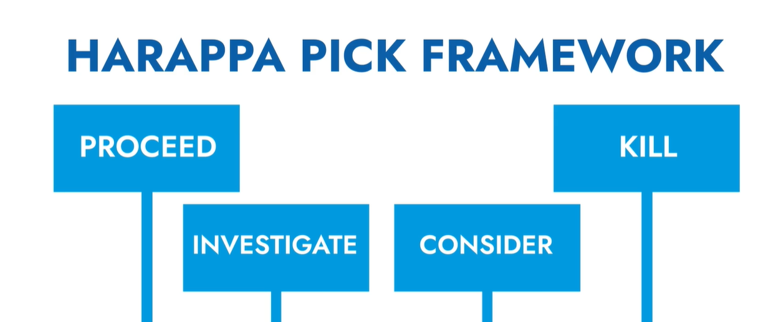

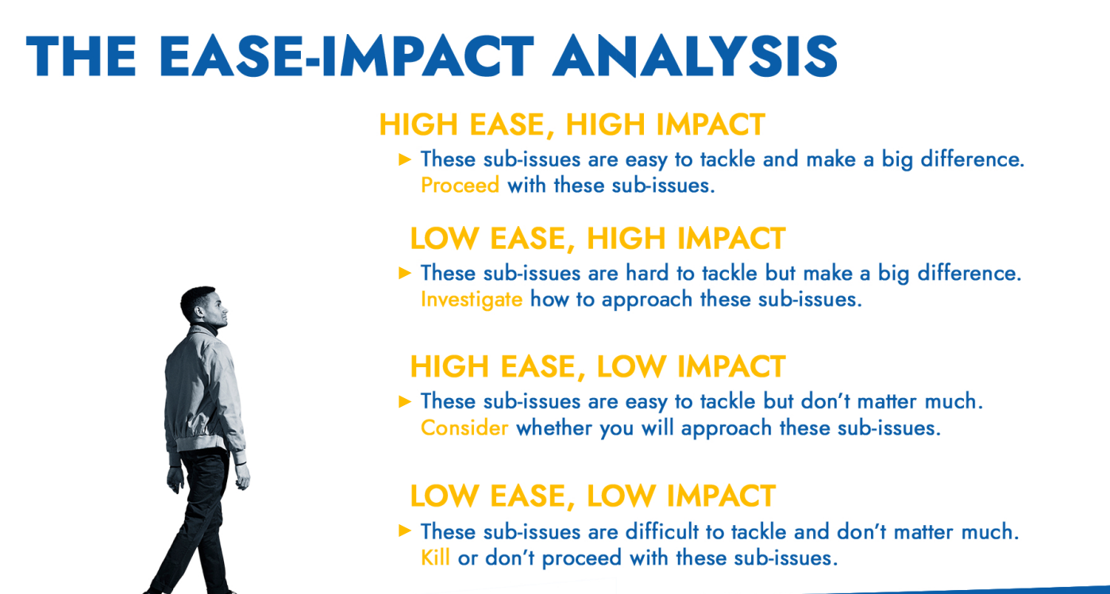

SWOT Analysis –

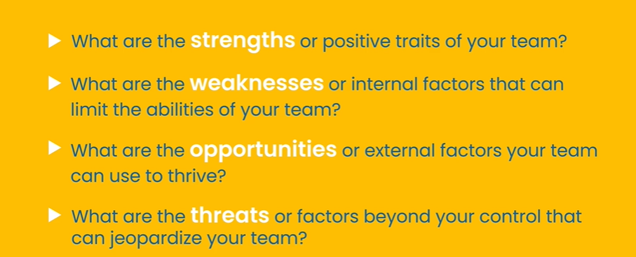

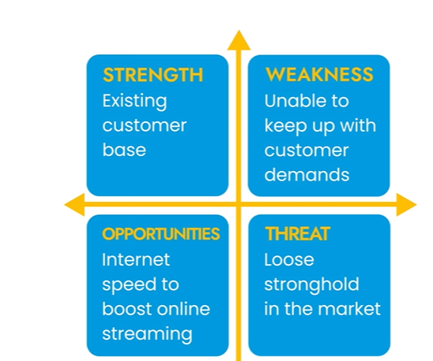

Pareto analysis helps to compare and contrast two or more problems.

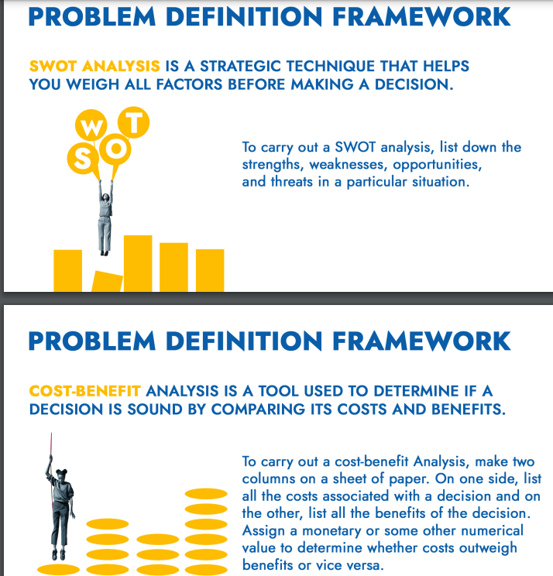

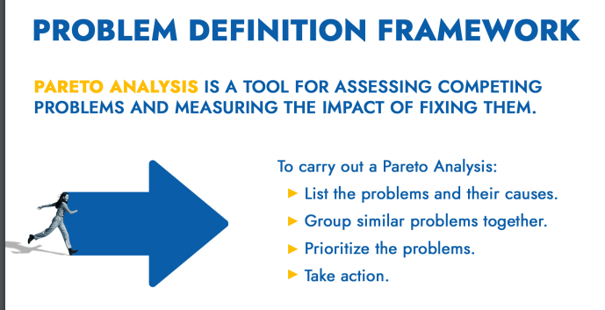

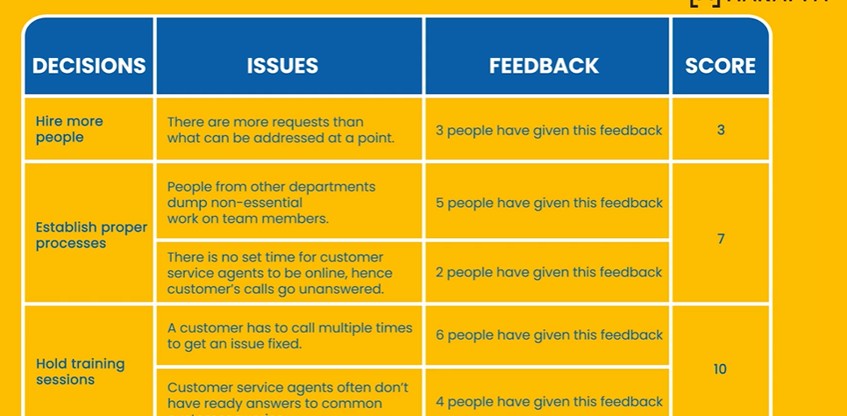

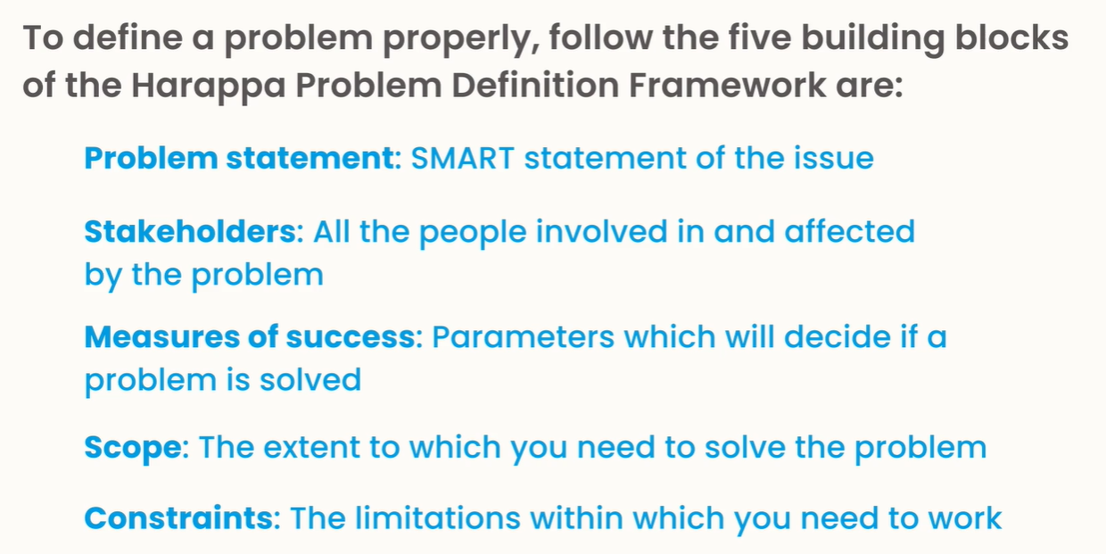

# Harappa YLP - Developing a Problem-solving Mindset

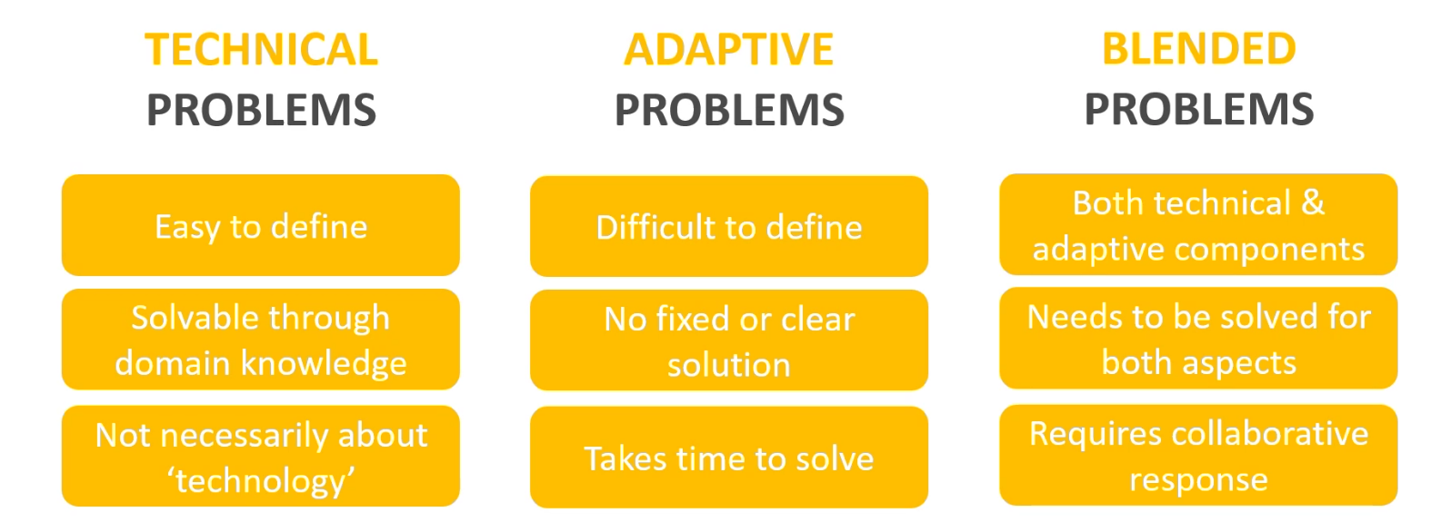

Magazines

# Digit FastTrack to Google Workspace

Google Workspace, formerly known as GSuite.

# Fast Track to WordPress

WordPress is an open-source, free platform for building and developing websites. WordPress is the most user-friendly and efficient blogging and website builder on the market right now.

WordPress is utilized by 43.2% of all websites live on the internet in the current year, 2022. This is an increase from 39.5 in 2021.

WordPress.com, primarily, is a managed host, while WordPress.org is not a host. In essence, WordPress.org allows you to host your website. In contrast, WordPress.com handles everything for you.

Anonymous comments can cause serious damage to your website’s reputation. To prevent individuals from submitting anonymous comments, choose the option “Comment author must fill out name and e-mail.”

WWW or no WWW – whether your website is brand-new or has been hosted for a few months already will depend entirely on its stage. If it brand-new, you must definitely choose whether to use www or non-www in the URL of your site.

# Digit Dmystify Heat

In all ways that heat is being generated, there is energy conversion happening. Heat is the internal energy of molecules constituting the body. It flows from a hot body to a colder one, when they are kept in contact with each other.

Kinetic and potential energy – in a cube of ice, the kinetic energy of molecules of water is low, but their potential energy is high.

One calorie of heat energy is the amount of energy that is required to raise the temperature of 1g of water from 14.5 degree Celsius to 15.5 degree Celsius.

The unit of heat is joule (J).

Temperature is defined as a parameter that helps us define the level of hotness or coldness of its body.

The process of measuring the temperature of body is called thermometry.

The quantity of heat that is absorbed by a body is generally dependent on three factors, which are as follows – mass, increase in temperature, material.

Higher the specific heat capacity of a material, the more heat energy is required to increase its temperature.

Not all the materials can have transfer of heat through this process, for example, plastic. Such material called insulators. Conductors are known to carry heat easily because of their low specific heat capacities.

The process of heat transfer through a vacuum is called radiation.

Mercury expands in size when heated. So in thermometers, when it is exposed to heat/rise in temperature, it expands, since it has nowhere else to go, but up the tiny slit that is created in the glass tube, it rises up, indicating the temperature of the body that it is in contact with.

# Digit Dmystify – Motion Sickness

Motion is a combined outcome of a body under observation and the observer. Types - translation or linear motion vs. rotational force.

If a body is in a state of rest of motion, it will remain in that state until an external force is applied on it.

Friction does not always hider movement; it often assists it. Like two boxes on kept one on the another, if you move one, the other one will also move.

A pool table is a great place to observe nearly elastic collisions. The interaction between pool balls when they hit each other is nearly elastic. The other type of collision, which is inelastic collision, is defined as a type of collision during which, upon contact there is a loss of kinetic energy. We generally get to see this energy being dissipated in the form of heat, light or sound.

# Digit Magazine + FastTrack + dmystify

Folks learning to code has increased by 60 to 70 % year-on-year.

Tor browser – once the user places the request for information in the browser, then a new node or Tor server is created at random by the browser.

Magnetism – The core of the earth was made from iron, while the planet itself was a magnet, which he quoted to be the reason for compasses to point to the north. The unit of the strength of a magnetic field is Tesla. Magnet types – permanent, temporary and electromagnets. A current-carrying wire produces a magnetic field around it. Magnet uses – scrap lifting, surgical extraction, dc motor, ac generators. The payment card strip is made of magnet, audio cassette, CRT’s monitor, speaker system. Over-exposure to static magnetic fields can be harmful to our health.

# Digit Dmystify Birds

Types - Vertebrates and invertebrates.

Birds characteristically have boney breaks, but no teeth.

The direct relationship between dinosaurs and modern birds is still under debate and up for researchers to find conclusive evidence against.

To identify what kind of diet a bird has is by looking at its beak.

In India, the national bird is the peacock, which symbolizes the diversity of the country and beauty that it brings to the place when it all comes together in one piece and dances to the tunes of the raindrops.

# Digit FastTrack to Ai (Acrobat Illustrator)

It is a computer graphics program to create intricate layouts, patterns and drawings. Capabilities – freehand drawings, colour palettes, fillings shapes, geometric objects, digital artwork, promotional or branded content, icons, website images.

Exercise – making a logo, create your own font, art of iconography, graphics, banner, charts like pies, bars, doughnuts, digital wallpapers.

Alternative tools – Inkscape, Vectr, CorelDraw, Figma, Affinity Designer, Sketch, Pixelied, Canva.

One of the top platforms now on the market is Adobe Illustrator.

# Digit dmystify Carbon

Carbon is the basis of all the life forms on Earth. To this date, several different carbon structures are being researched on. It has three main allotropes – diamond – the hardest substance known to humans, diamond has a three dimensional structure in which carbon atoms are held together by strong covalent bonds. Graphite and Buckminsterfullerene – also known as Fullerenes and they are the best example of unadulterated type of carbon.

Coal is divided into the following four categories – peat, lignite, bituminous and anthracite.

# Digit FastTrack to Coding in 2022

According to the Stack Overflow Survey 2022, there has been a 60 to 70% year on year increase in the number of students who want to learn coding online.

JavaScript was originally called Live Script, Netscape changed its name to JavaScript, and it is believed that this was because of the hype of Java within the industry.

Fastify provides a faster alternative for Express.js.

Python is an interpreted, general-purpose high-level programming language that is mainly used for automation, website development and data analytics. Python is managed by the Python Software Foundation.

When compared to compiled languages like C and C++, the python code is generally short, however, it executes programs slower.

Low-code no-code (LCNC)

HTML was invented by Tim Berners-Lee in 1993. Modern HTML codebases are now shorter than what they used to be. A huge number of interactive and design elements that programmers rely on to code manually can now be handled with the help of CSS or JS.

Game development – before HTML, a developer could only do this with the help of Flash or Silverlight.

HTML can interact with our OS and not just the browser, features like easy to drag files onto a webpage so that we can upload them or made a video display on full-screen.

CSS was established in October 1994 by Hakon Wium Lie, who was a Norwegian web pioneer. Lie was sick of the lack of styling options that were available to developers.

By using Spring, JSF, Hibernate, Struts and Apache Hadoop, we can develop web-based programmes in Java. It is also a official programming language for Android development.

SQL – Structured Query Language.

NoSQL was created to function as a support system for SQL, not as its replacement. The language is based on a model that is considered to be fairly less stringent.

The term # in C# is derived from the musical sharp key. This symbol is used to denote a one semitone increase in pitch. C# is known for improving and updating many C and C++ feature.

Rus is often labelled as an alternative to traditional C++. Rust prevents memory leaks, which means there would be fewer errors in the work. As Rust is also considered a rather low-level language, it really comes in handy when developers need to get more gains more out of the minimal resources they have.

In contrast to this logic, high-level dynamically typed languages (form instance, Python and JavaScript) are considered to be better for tasks related to quick prototypes.

Perl (Practice extraction and report language) – one of the most common uses when it comes to Perl is executing text file information as well as generating a report or other output format. This is an interpretive language as opposed to a compile language. Now most uncompiled programs need a lot more CPU run time. This language was initially created only for text handling and system management. Currently, this language is known for its capabilities regarding handling Regex.

Go – developed very much in the same way as Algol or C. The defining feature of Go is concurrency means many different processes can easily be executed simultaneously. The main goal of this experiment was to address some of common criticisms pertaining to other programming language while also making sure that the still retain their most useful features.

Many different languages have similar structures and patterns. We need to get out of the mindset of believing that certain coding languages are better than others.

A great way to understand more about the world of coding is by looking at the work done by developers before you.

Some of the top websites that often open source projects include – gihub explore, code triage, open source Friday, source sort, first timers only, first contributions, up for grabs, 24 pull requests.

We should not create any features of functionality when we are carrying out the refactoring process.

Browse daily and get new information – code chef, code wars, coding game, geektastic, hacker rank, leet code, project euler, spoj, top coder, exercism.io, codebyte.

If we find a person with a rare intellect, we should ask him about the books he reads. Without good reading and comprehension skills, a person takes more time to understand the problems before solving it. Books that every programmer must read once – the mythical man month by Frederick brooks, the pragmatic programmer: your journey to mastery, code complete 2 by steve mcconnell, the art of computer programming, programming pearls, code: Charles petzold, introduction to algorithms, refactoring: improving the design of existing code, design patterns: elements of reusable object-oriented software.

# PC Quest April – May 2022

Most successful computer magazines including PC magazine, Macworld and PC World.

After the Janata party government came to power in 1977, thank to FERA, foreign companies couldn’t not won majority shares and they had to dilute Coca Cola and IBM said sorry we are not diluting and left.

In those days had to provide a 100-page justification on why you wanted to import the computer, how it would affect the country, and hold your breath, how it would affect the agricultural sector along with disk mapping and memory mapping.

Since we were aligned with the soviets, there was also a lot of pressure to buy Russian computers. In those days a PC went for a lakh of Rupees and a mini for 3-4 lakh because the duties were high, to the tune of 150%.

We created the idea of franchise for education which had never been done before. We found like-minded entrepreneurs in cities and motivated them to go back to their town and setup and NIIT centre.

Assembled PCs started somewhere I would say in 1985-86 when a lot of these components from Taiwan started coming in individually for people to assemble it.

The assembled desktop PIC is very much there for the gaming purposes. As far as the gaming market is concerned, 90% is assembled.

LANs have gone to WANs and from twisted pair cables and coaxial cables to becoming wireless radio, satellite, Bluetooth, infrared, Wi-Fi, mobile, NFC, and now high speed 5G have made networking unrecognizable from what it was back in the 80s.

It was a time where knowledge was not freely available and expertise lay in the hands of a chosen few.

We at Sify rolled out 5000 cybercafes in 18 months.

India could have skipped 3G and gone to 4G directly.

In the mid-1990s we all got wired up and our computers got attached to servers globally. If I was to call it remote work 1.0. connectivity went to the next level when data, devices and digital came together in about 2004-05. The next level of what I would call remote 2.0 continues till now. It is being driven by video and great collaboration tools.

Location premium jobs which can be codified will go away. But some jobs which need creative iteration between teams, in person collaboration, brainstorming, I don’t think we have been able to crack that code yet.

My advise to the students is that you should understand which part can be done easily online and which part you should bring in the social or interaction element. Once you are clear on that, you will not have to spend a lot of time in front of the laptop. Once you know the concept, then you do your discussion in the classroom with your teacher.

Because of three reason, our education system is not accessible to everyone, it is not affordable to everyone and the quality is great that it excites everyone.

With AI you could covert your speech into gestures with ta visual robotic movement.

Worldwide universities grow with research and not just with teaching.

One of the big successes of open source was in operating systems: Linux.

Semiconductors have often been called “the crude oil of the information age”.

5G is important because it offers crucial benefits such as privacy, personalization, and reliability, besides scaling intelligence and enabling faster decision-making.

Let’s say a salesman wearing on of these devices will see the linkedin bios of everyone who’s walked into the room and has a lot more context about the person he is speaking with. That’s going to be superhuman compared to someone not wearing the glasses.

# Digit FastTrack to Upskilling

Young bright minds ready to snipe every job opportunity that comes their way.

As a technology journalist you may have to go out in the field to interview developers or anyone who works in a new software.

Containers effectively virtualize the host operating system or kernel and isolate an applications dependencies from other containers running on the same machine.

Texture artists create the final skins on top of 3D models for computer generated imagery. They bring polygons to life by simulating the look and feel of real world material and textures. Every scene for a texturing artist is a new world to explore as their job is to make it photoreal. You have to learn things like texture, colour, dimension, scale, perspective, shade, composition, depth of field, proportion, lighting and spatial awareness.

Foley artists give life to shapes like footsteps, actors walking in leg chains. They reproduce every day sounds like waves crashing, rain coming down, cars passing by, punches, kicks, wind blowing, doors slamming. Three major kinds – feet, movement, specifies. Like roaring of a tiger in a scene or helicopters flying over the heads of the actors in a scene are produced by artists working on specifics.

# Digit FastTrack to Buying a Smartphone in 2023

The clock speed of a processor determines how many instructions can be executed by a processor per second.

SoC stands for System on Chip.

Smartphone displays are categorized into three categories – LCD, LED and Retina Display.

AMOLED developed by Samsung and can project true black colours. LED display developed by LG. Retina display is essentially an IPS LCD or an OLED display that was modified and renamed by Apple.

A phone that receives an IP (Ingress Protection) rating of IP67 is termed as dust resistant and can be immersed in 1m freshwater for up to 30 minutes.

Smartphone will have two speakers one for get a call and other one is the main speaker. Main components of speakers are diaphragm, voice coil, magnet and a speaker. Diaphragm basically moves according to the current created and the pressure waves that they create that is responsible for generating the sound waves.

# Digit April 2023 The Artificial Issue

Non-playable characters (NPC) have played a vital role in creating immersive and realistic virtual words. Whether it is a shopkeeper, a quest-giving NPC, or a side character, NPCs help players feel like they are a part of living. The ultimate NPC should possess human-like qualities such as emotions, personality, and the ability to learn from experiences. They should be able to interact with players in a natural and intuitive way and respond to a player’s actions and choices.

Developers can use motion capture technology to create more natural and realistic movement for NPCs. This technology involves recording the movements of a human actor and applying them to an NPC’s model. This technique can help create more lifelike animations and movements that look and feel natural.

# Digit FastTrack to AI Apps

Machines can generate content, but they can’t replicate the nuances and personality of writer’s voice.

Adobe’s lightroom CC now includes a “Best Photos” feature that automatically selects the best photo from a group of related images.

AI is also viewed as a “risky fix” and a “runaway process” in science , with potential unforeseen outcomes that could reshape knowledge production.

# Digit Fast Track to Android App Development

Potential languages – popular programming languages used by Android app developers – Java, C#, C++/C, Python.

Kotlin was created by JetBrains. In 2017, google endorsed Kotlin as an official language for Android Development and has since provided support for its development.

C++ is a high-performance compiled language, meaning its code is transformed into machine-readable code, making it one of the fastest programming languages available.

Google developed the open-source programming language Dart, which supports both client and server-side application development. Dart is extensively used for developing Android and iOS apps.

Ansca Mobile developed a cross-platform mobile development framework called Corona SDK. The Corona SDK is built on top of the Lua programming language.

Gradle build system - Android Studio uses the Gradle build system to manage the build process of an Android app. To automate the process of building, testing, and deploying their app. They can define dependencies, set build configurations, and automate the build process using Gradle.

Publishing Apps – Developers can create a listing for their app, upload screenshots and videos, and set pricing and availability.

Prepare your app for release – test you app thoroughly, optimize your app, secure your app, include relevant metadata, set up a google play console account.

Promote your app – use social media, use app review sites – reach out to app review sites and ask them to review you app, advertise you app on google AdWords, offer special promotions and discounts, reach out to influencers.

Respond to user feedback, choose a catchy app nae and write a compelling app description, use high quality screenshots and videos.

Choosing the right platform – google play store, apple app store (a reputation for being more selective than google play store, there are a ton of restraints on the Apple App Store), amazon Appstore (primarily used on Amazon’s Fire tablets and Fire TV devices), Samsung Galaxy Store, Xiaomi App Store.

Freemium – providing a free, basic version of the app with the option to upgrade to a premium, paid version.

Technical skills – programming languages – java, swift, Kotlin, python, frameworks – react native, flutter and Xamarin is crucial for efficient cross-platform app development.

# Digit – Back to School – May 2023

SNES 8-bit games.

# Fast Track Prompt Engineering

By crafting precise instructions or prompts, prompt engineers can shape the behavior of AI models, ensuring the desired output.

Good prompts –

* Create an abstract painting that uses a color scheme of blues and greens, with flowing brush strokes and a circular composition.
* Generate a surreal landscape, you can use prompts like “twisted trees”, “floating mountains” and “alien sky”.
* Create a piece of music that is uplifting and optimistic.

# Digit Tech Myths Busted (July 2023)

Deep web vs dark web – deep web refers to all parts of the internet not indexed by search engines like google or Bing like private databases, restricted forums and paid content. The dark web is a small part of the deep web that is intentionally hidden from traditional web browsers and can only be accessed with specific software.

# FastTrack to PC Maintenance Part 2

OSD (on-screen display) controls – the OSD controls are buttons or a touchpad on the monitor that allow the user to adjust the settings, such as brightness, contrast, and color temperature.

There is no need to defragment the SSD as they do not work the same way as traditional hard drives. In fact, defragmenting an SSD can cause unnecessary wear and tear on the drive.

To prevent screen burn-in, avoid displaying static images or leaving the monitor on for long periods of time. Use a screensaver or power-saving mode when monitor is not in use.

# Digit FastTrack to Home Automation

Communication protocols can be defined as a set of rules and procedures that govern the exchange of data between devices in a network. They determine how devices communicate, the format of data transmission, and the protocols used for error detection and correction.

# Digit February 2023

Mirrorless camera.

# Digit FastTrack to Audio Production

A good song will develop as it goes along, taking us on a familiar path sprinkled with surprises along the way to make sure we are listening. A bad song, on the other hand, will remain stagnant throughout its entirety.

Noise reduction – getting rid of sounds that aren’t natural to your environment should be at the top of your to-do list at all times.

Equalization will bring out the frequencies that make the dialogue sound more attractive, push back some of the low end, and allow a good performance to come through.

# PC QUEST – The Next Tech Revolution (January 2023)

In windows 11 we can see battery usage graph for analyzing its performance, enable storage sense to auto cleans up storage time to time.

# PC QUEST – Assistive Technology (February 2023)

Assistive technology refers to any device, software or system that is designed to support individuals with disabilities and improve their functional capabilities. Examples – wheelchairs, speech recognition software, and adapted keyboards.

Adaptive technology, on the other hand, refers to technology that has been modified of an individual with a disability. For example, adaptive mouse might be modified to accommodate the needs of an individual with limited dexterity.

Artificial general intelligence (AGI) is a type of AI that is capable of learning or understanding any intellectual task that a human being can. AGI is not trained to carry out a specific task, it is able to learn new skills and knowledge on its own just like a human without explicit programming.

Overclocking will make your phone run hotter and shorten your battery life, but I can squeeze every drop of power out of your device.

# Digit FastTrack to Stable Diffusion

Stable diffusion is a latent text-to-image diffusion model capable of generating photo realistic images given any text input. The model employes a technique called diffusion modelling, which works by incrementally reducing the noise in a sample over several iterations, eventually producing a final output.

The Frechet inception distance (FID) metric is commonly used to evaluate the quality of images generated by generative models. FID calculates the distance between he feature vectors of real and generated images.

Limitations of Stable Diffusion – built-in blockers to prevent misuse, western cultural influences to dominate the outputted images.

Three main component in latent diffusion – autoencoder, U-Net, text-encoder.

As AI becomes more advanced, it may be able to create art that is indistinguishable from that of human artists, potentially displacing them from their careers.

AI-generated film is still in its early stages, but with stable diffusion, you can create basic animations as either a GIF or a video file.

The rise of generative AI is a revolution for gaming sector. I game art creation is now more efficient, affordable and produces higher quality results thanks to AI. A process that once took artists weeks to complete can now be accomplished in a matter of hours.

AI-generated paintings are causing controversy among artists who feel that their work is being ripped off without proper credit.

Diffusion model is a type of model that generates a chain of increasingly noisy images by adding Gaussian noise to an image and then training a model to predict the noise added to an image from one step to following one. It uses a fixed and finite number of steps to generate images, resulting in a stable repeatable image generation.

# Digit – Women in Tech (March 2023)

AnTuTu is a software benchmarking tool commonly used to benchmark smartphones and other devices. It is owned by Chinese company Cheetah Mobile.

# FastTrack to Unreal Engine 5

The first notable gaming engine emerged in the 1980s. Bill Budge’s Pinball Construction Set (1983). The Unreal Engine by Epic Games. Types of actors – static actors, dynamic actors, pawns, character actors.

# [youtube.com] How product companies handle production downtime

They use website like ManageEngine.com.

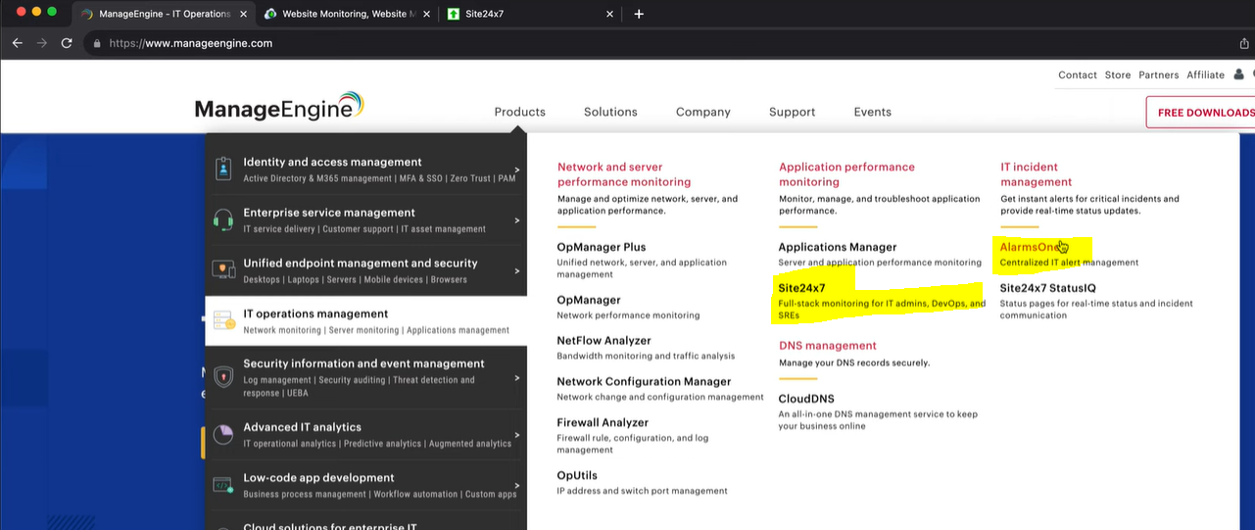

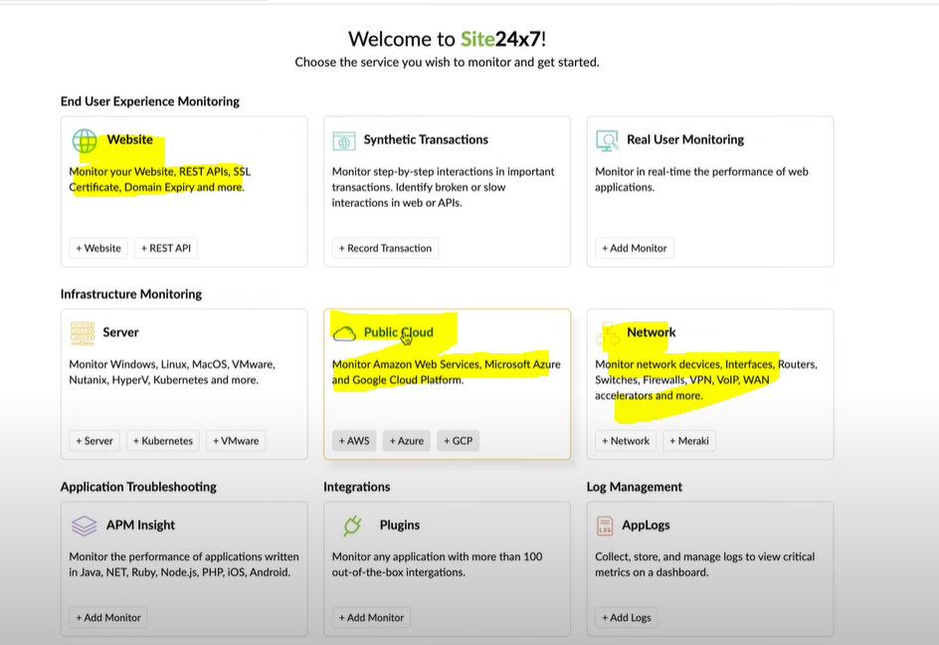

# Digit FastTrack – Android App Development (Foldables Edition)

An app that seamlessly transitions between folded and unfolded states is essential for user satisfaction. Smartphone design moving away from traditional, rigid form factor to a more flexible and adaptable one. Two types – book-style and claimshell-style.

These devices, which can switch between a phone and table-like format, are a promising frontier for developers and designers alike. Users expect between different screen sizes and orientations.

Challenges include handling multiple screen ratios, dealing with screen continuity, and ensuring a seamless transition between folded and unfolded states.

# Digit – October 2023

A subscription-based model for the supposed next iteration of windows a.k.a. windows 12. Linux has only attracted more gamers towards the cult of Linux.

# Digit FastTrack to Notion

Content creation and formatting are the bedrock of Notion.

The database functionalities, interlinked pages, and project management features are realms where Notion outshines.

# Book – Programming Pearls

The programs use a terse coding style: short variable names, few blank lines, and little or no error checking.

A merge sort program reads the file once from the input, sorts it with the aid of work files that are read and written many times, and then writes it once.

Careful analysis of a small problem can sometimes yield tremendous practice benefits.

A designer knows he has arrived at perfection not when there is no longer anything to add, but when there is no longer anything to take away. Simple programs are usually more reliable, secure, robust and efficient than their complex cousins, and easier to build and to maintain.

Good programmers are a little bit lazy: they sit back and wait for an insight rather than rushing forward with their first idea.

Coding skill is just one small part of writing correct programs. The majority of the task is the subject of the tree previous columns: problem definition, algorithm design, and data structure selection. If we perform those tasks well, writing correct code is usually easy.

The first binary search was published in 1946, the first published binary search without bugs did not appear until 1962.

If run time doesn’t matter, linear search is much simpler than binary search; many programmers can get it right on the first try. Because run time is important enough for us to introduce the additional complexity of binary search, we should conduct experiments to ensure that is performance is what we expect.

Rick Lemons said that the best lessor he ever had in debugging was watching a magic show. The magician did a half-dozen impossible tricks, and Lemons found himself tempted to believe them.

Inefficient programs sadden their users with longs waits and missed opportunities.

Everything should be made as simple as possible, but no simpler.

Premature optimization is the root of much programming evil, it can compromise the correctness, functionality and maintainability of programs.

Insertion sort is the method most car players use to sort their cards. Insertion sort is simple to code and may be fast enough for small sorting jobs. For large numbers, run time of Quicksort is crucial.

One part of a programmer’s job is solving today’s problem. Another, and perhaps more important, part of the job is to prepare for solving tomorrow’s problems.

Heapsort never takes more than O(n log n) time to sort and n-element array, and uses just a few words of extra space. The fasters Heapsort is usually slower than the simple Quicksort.

Make it work first before you make it work fast.

Sorting works well for finding the mode, but hashing can be faster.

# HTTP crash course

URL, URI and URN are almost same to get the location address.

Types of headers – X-prefix for headers has been deprecated.

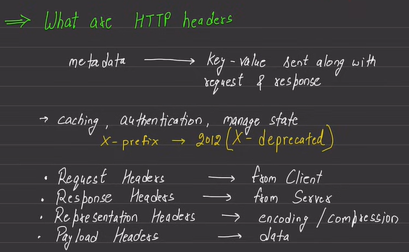

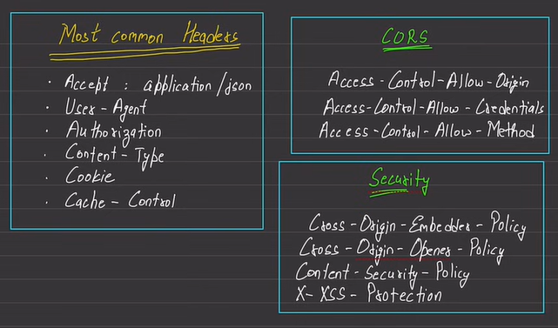

We also have methods like HEAD, TRACE. TRACE is useful to have debugging in case of multiple proxies in-between the communication.

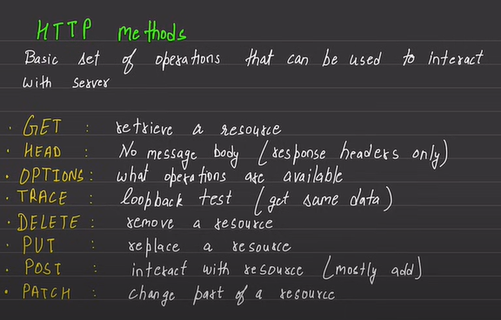

Useful status code –

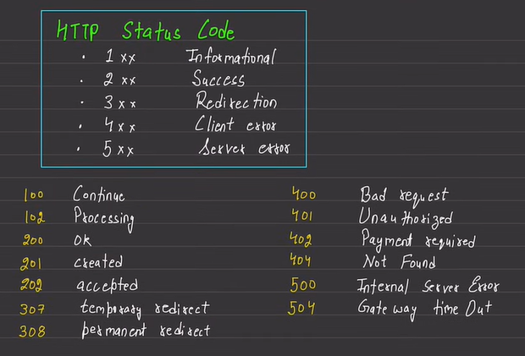

Reverse Proxy – Nginx and caddy are example of reverse proxy servers.

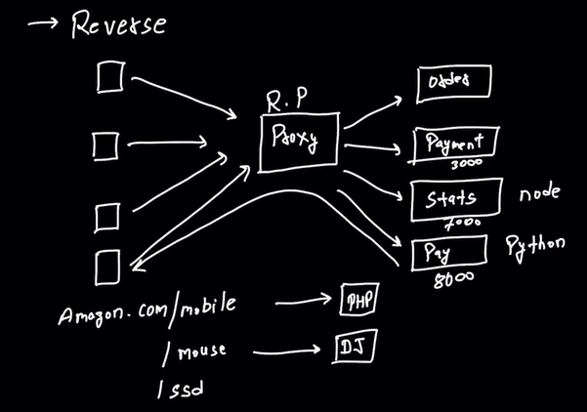

# Others – Mind Mapping

Do not write too much text.

Delayed note taking. Listen think, analyze and write.

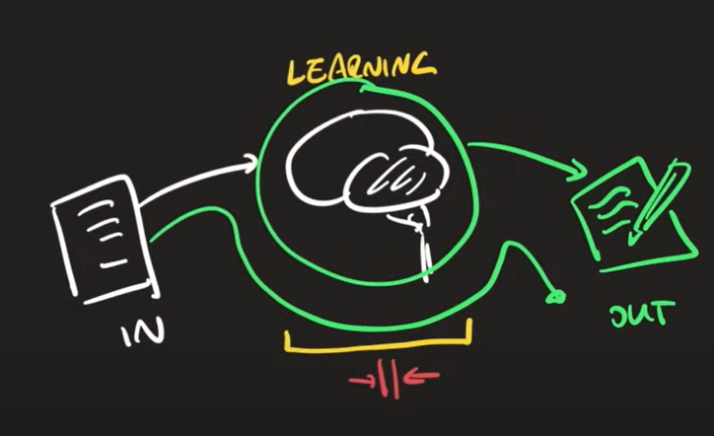

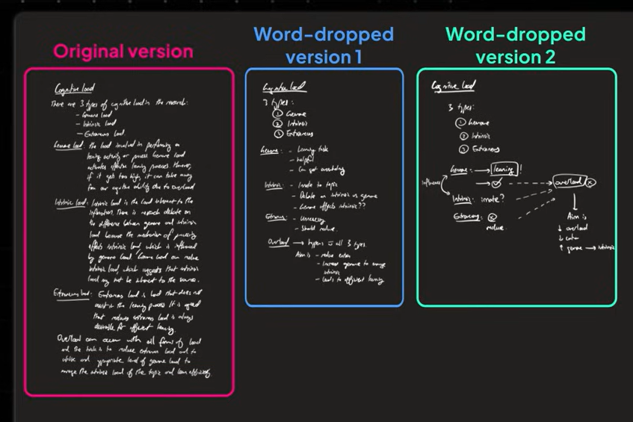

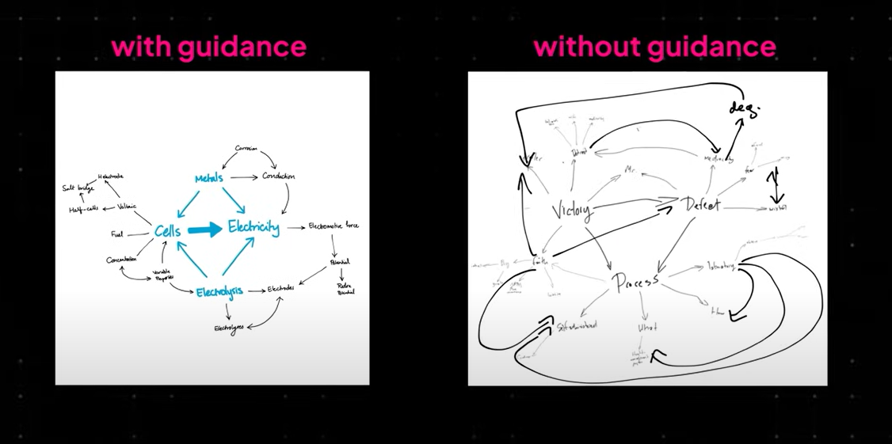

The lifecycle of a Kubernetes pod –

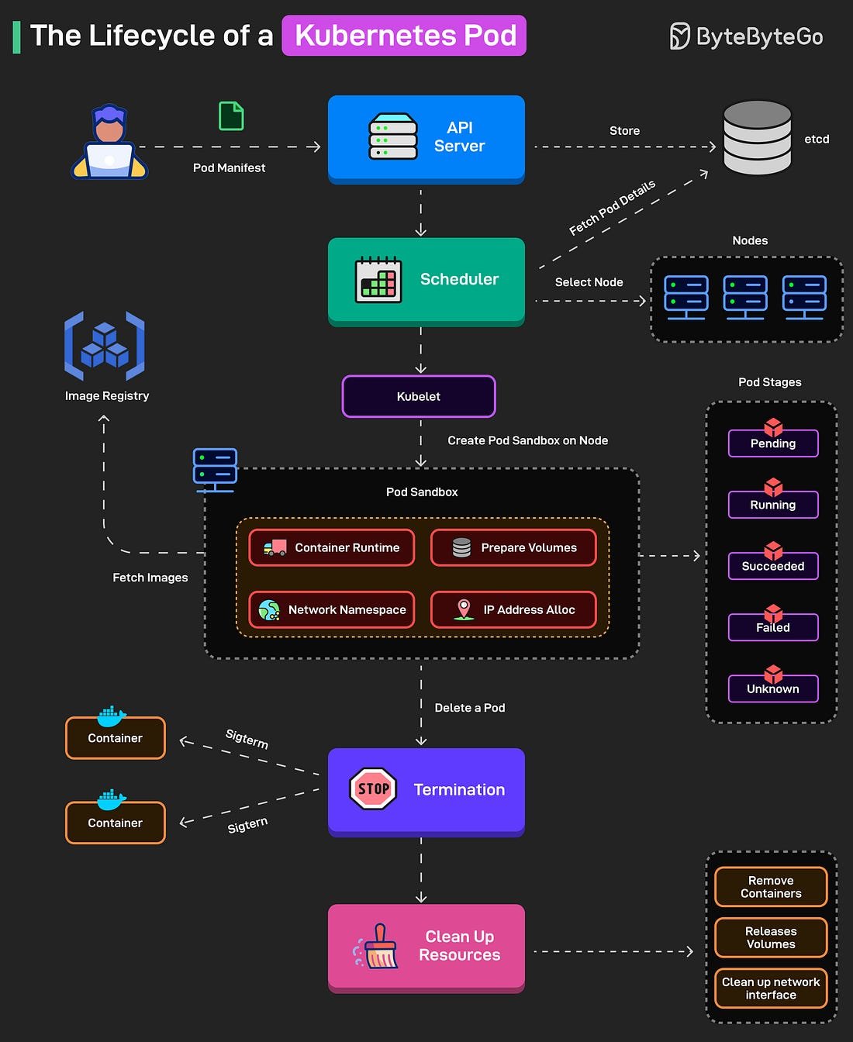

Common versioning strategies –

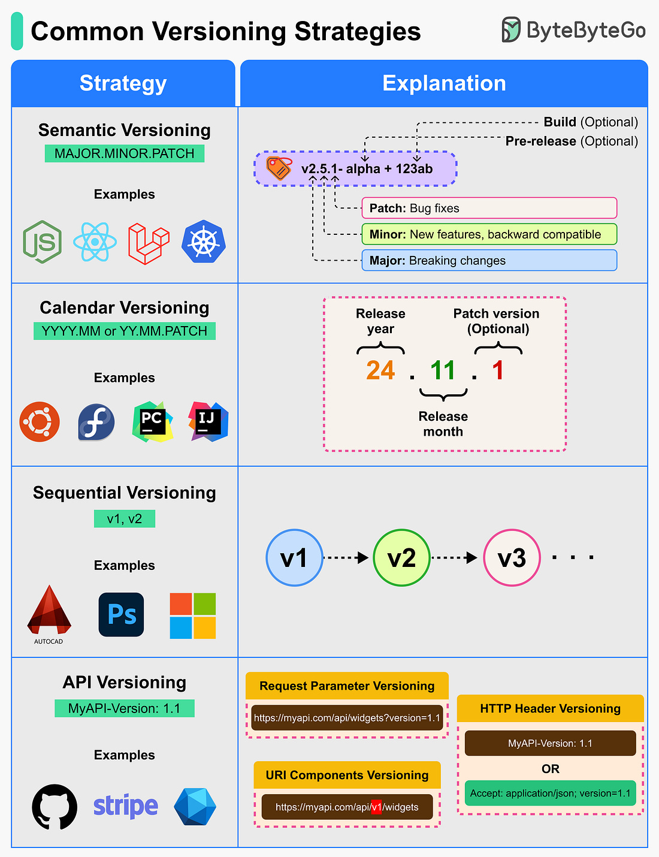

The testing pyramid –

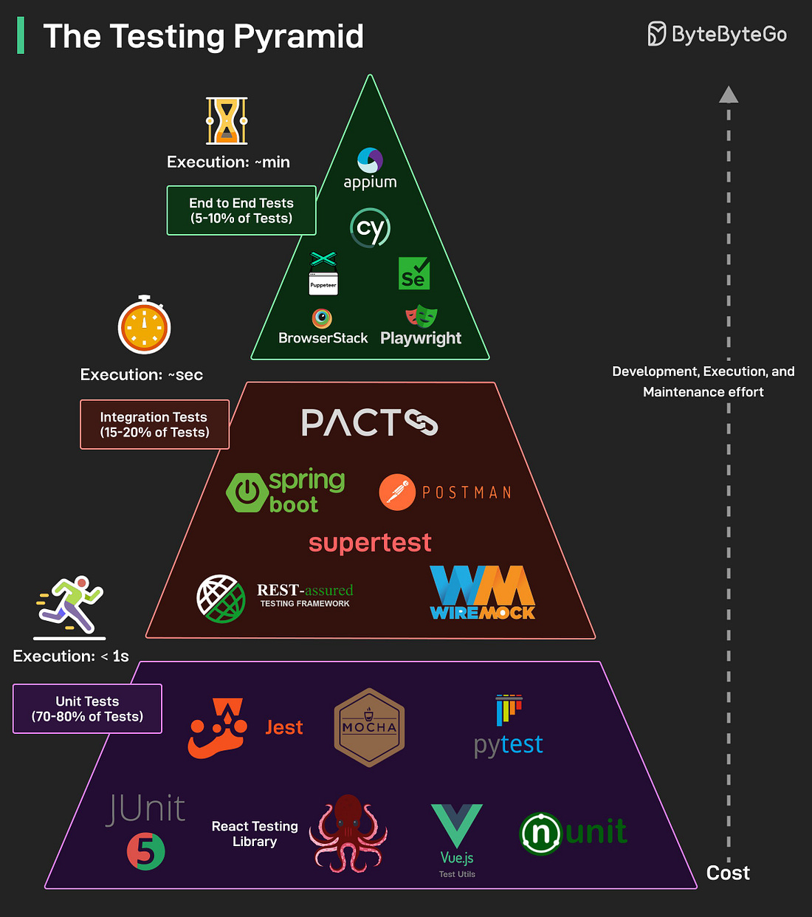

How RAG Works?

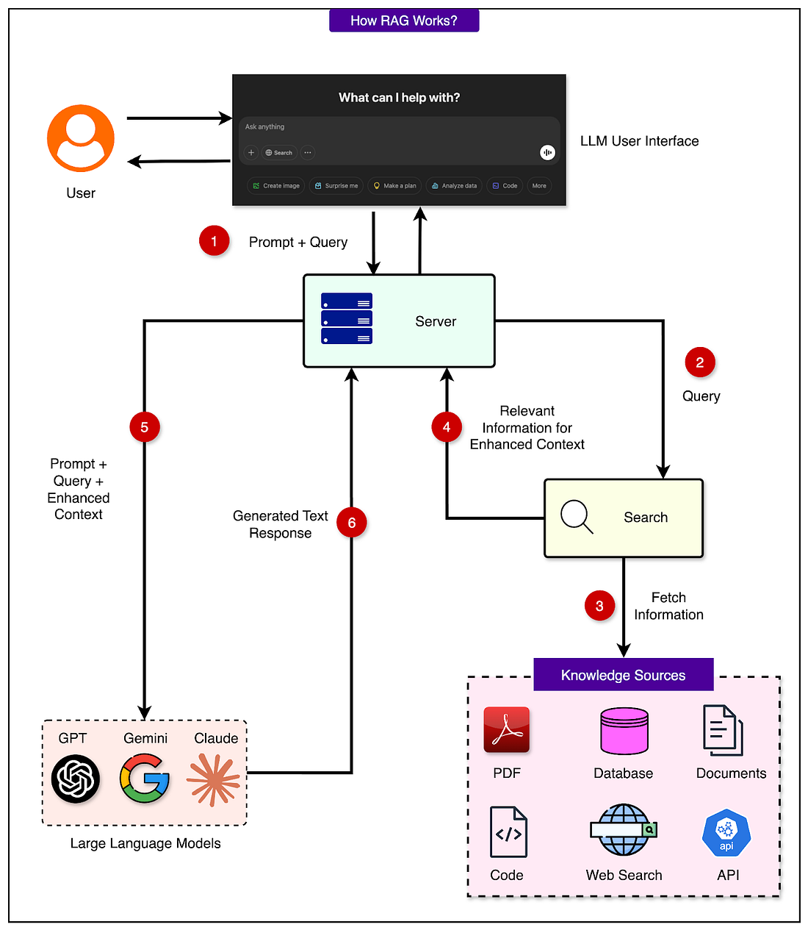

How AI Agents works?

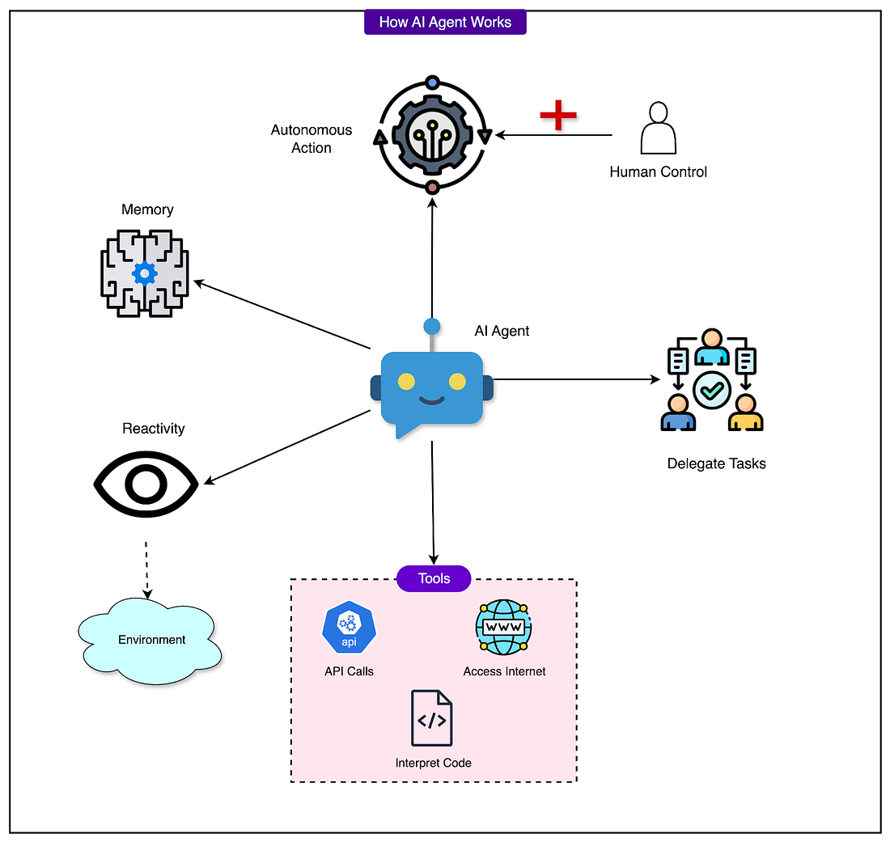

# Digit Magazines

Active noise cancellation (ANC), which, as the name suggests, actively cancels the ambient noise and there is also environmental noise cancellation (ENC), which cleans up our sound that goes out to others during calls. While ANC reduces all surrounding noise for the listener, ENC focuses on filtering out most of the background noise so the user’s voice sounds crystal clear to the recipient. ANC headphones should be able to block low-frequency sounds such as engine noise or air conditioning hum. High-frequence noises, including human speech, may not be fully eliminated.

If your budget allows, consider OLED or QLED for richer contrast and colors compared to regular LED TVs.

Buying a laptop – students care about GPU cores for AI projects, hybrid workers want Wi-Fi 7 for crowded flats, and creators won’t settle for washed-out display

AI running on the NPU, give us faster responses and better privacy compared to cloud-based AI services.